

In Search of Sustainability in Energy

[](https://enrichenergy.com/about-us/)

[About](https://enrichenergy.com/about-us/)

[](https://enrichenergy.com/projects)

[Projects](https://enrichenergy.com/projects)



Offerings

[](https://enrichenergy.com/clientele)

[Clientele](https://enrichenergy.com/clientele)



Careers

[](https://enrichenergy.com/contact-us)

[Reach Us](https://enrichenergy.com/contact-us)

[(https://enrichenergy.](https://enrichenergy.com/about-us/)[(chottmps/a:/b/eonurti-chenergy.com/projects)](https://enrichenergy.com/projects) [(https://enrichenergy.com/clientele)](https://enrichenergy.com/clientele) [(https://enrichenergy.com/contact-](https://enrichenergy.com/contact-us)

[us/)](https://enrichenergy.com/about-us/) [us)](https://enrichenergy.com/contact-us)

**REACH US**

#### Business Offerings

Integrated, efficient, reliable and honest solutions that are built based on our years of experience in design, development, maintenance, and considering your diverse needs and requirements.

[(https://enrichenergy.com/business_offerings/turnkey-solutions/)](https://enrichenergy.com/business_offerings/turnkey-solutions/) [(https://enrichenergy.com/business_offerings/epc-solutions/)](https://enrichenergy.com/business_offerings/epc-solutions/)

[(https://enrichenergy.com/business_offerings/rooftop-solutions/)](https://enrichenergy.com/business_offerings/rooftop-solutions/) [(https://enrichenergy.com/business_offerings/energystorage/)](https://enrichenergy.com/business_offerings/energystorage/)

[(https://enrichenergy.com/business_offerings/om-services/)](https://enrichenergy.com/business_offerings/om-services/) [(https://enrichenergy.com/business_offerings/value-added-services/)](https://enrichenergy.com/business_offerings/value-added-services/)

700+

MWp commissioned

300+

MWp under installation

600+

MWp under O&M

302

Million units generated every year

#### Why Us?

**CREDIBLE**

1

Track record of **~1 GWp** (executed /under execution) projects over 13 years

**GLOBAL STANDARDS**

Designs comply with IEC, EN, IS, BS & ASTM

4

Processes as per to ISO 9001, ISO 14001 & OHSAS 18001

**CAPABLE**

2

Experienced **team of 300+** with deep expertise in Land & PE, Design, SCM, Project, Operations & Consulting

**KEEPING PACE WITH TECHNOLOGY**

Experience of working with all leading technology products and proactively adopting latest technology in to business & offerings

5

**CUSTOMER-CENTRIC**

3

100+ customers across C&I, PSU and IPP segments with exceptional rate of repeat orders

**END TO END SOLUTION PROVIDER**

One stop solutionprovider with proven capabilities across the value chain from esign to Lifecycle Asset Management, to create and protect value of customer’s assets

6

#### Projects Testimonials Clientele News



[NLC](https://enrichenergy.com/clientele/)

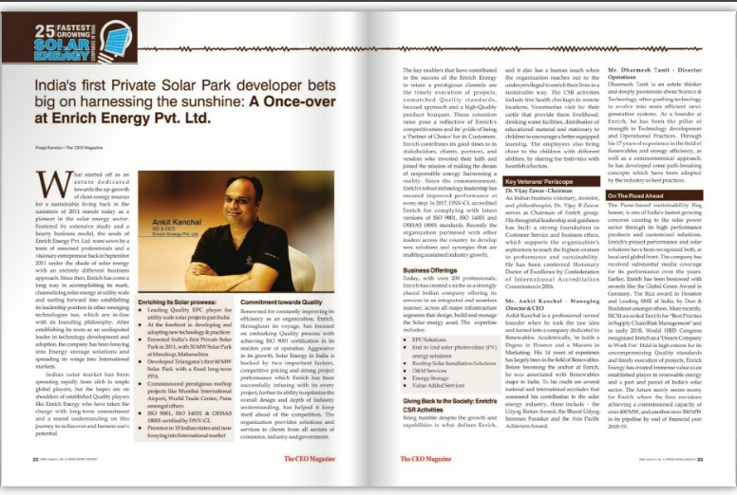

Enrich Energy listed amongst fastest growing Solar & Energy companies

[s://enrichenergy.com/p(rhotjte](https://enrichenergy.com/projects/)p

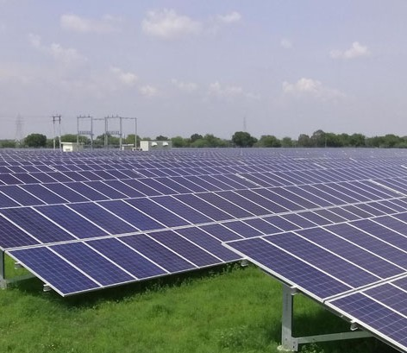

[**50 MW**](https://enrichenergy.com/projects/)

[Solar Park Mandrup,](https://enrichenergy.com/projects/) [Maharashtra](https://enrichenergy.com/projects/)

[(testimonials/)](https://enrichenergy.com/testimonials/)

[*"Enrich Energy has surpassed our qualification process and in our opinion has the credentials and ability to execute such projects in India"*](https://enrichenergy.com/testimonials/)

[Eren India](https://enrichenergy.com/testimonials/)

[(clientele/)](https://enrichenergy.com/clientele/)

About Enrich

[Promoters](https://enrichenergy.com/promoters)

Projects

[View All Projects](https://enrichenergy.com/projects)

Business Solutions

[EPC Solutions](https://enrichenergy.com/business_offerings/epc-solutions/)

[Clientele](https://enrichenergy.com/clientele) [(https://enrichenergy.com/clientele)](https://enrichenergy.com/clientele)

[(https://enrichenergy.com/promoters)](https://enrichenergy.com/promoters)

[Achievement](https://enrichenergy.com/achievements)

[(https://enrichenergy.com/projects)](https://enrichenergy.com/projects)

[End to End](https://enrichenergy.com/projects/#home)

[(https://enrichenergy.com/business_offerings](https://enrichenergy.com/business_offerings/epc-solutions/)[M](https://enrichenergy.com/video)[/ep](https://enrichenergy.com/business_offerings/epc-solutions/)[e](https://enrichenergy.com/video)[c-](https://enrichenergy.com/business_offerings/epc-solutions/)[dia Center](https://enrichenergy.com/video)

[solutions/)](https://enrichenergy.com/business_offerings/epc-solutions/)

[(https://enrichenergy.com/achievements)](https://enrichenergy.com/achievements)

[(https://enrichenergy.com/projects/#home)](https://enrichenergy.com/projects/#home)

[End to End Solutions](https://enrichenergy.com/business_offerings/end-to-end-solutions)

[(https://enrichenergy.com/video)](https://enrichenergy.com/video)

[CSR](https://enrichenergy.com/csr) [(https://enrichenergy.com/csr)](https://enrichenergy.com/csr)

[EPC](https://enrichenergy.com/projects/#menu1)

[(https://enrichenergy.com/business_offerings](https://enrichenergy.com/business_offerings/end-to-end-solutions)[B](https://enrichenergy.com/blogs)[/en](https://enrichenergy.com/business_offerings/end-to-end-solutions)[lo](https://enrichenergy.com/blogs)[d-](https://enrichenergy.com/business_offerings/end-to-end-solutions)[g](https://enrichenergy.com/blogs)

[Brochures](https://enrichenergy.com/wp-content/uploads/2017/12/Enrich-Energy_Corp-Brochure_2017.pdf)

[(https://enrichenergy.com/projects/#menu1)](https://enrichenergy.com/projects/#menu1) [to-end-solutions)](https://enrichenergy.com/business_offerings/end-to-end-solutions)

[(https://enrichenergy.com/wp-](https://enrichenergy.com/wp-content/uploads/2017/12/Enrich-Energy_Corp-Brochure_2017.pdf)

[IPP](https://enrichenergy.com/projects/#menu2)

[Rooftop Solutions](https://enrichenergy.com/business_offerings/rooftop-solutions/)

[(https://enrichenergy.com/blogs)](https://enrichenergy.com/blogs)

[content/uploads/2017/12/Enrich-](https://enrichenergy.com/wp-content/uploads/2017/12/Enrich-Energy_Corp-Brochure_2017.pdf)

[(https://enrichenergy.com/projects/#menu2)](https://enrichenergy.com/projects/#menu2) [(https://enrichenergy.com/business_offerings/rooftop-](https://enrichenergy.com/business_offerings/rooftop-solutions/)

[Energy_Corp-Brochure_2017.pdf)](https://enrichenergy.com/wp-content/uploads/2017/12/Enrich-Energy_Corp-Brochure_2017.pdf)

[Rooftop](https://enrichenergy.com/projects/#menu3)

[solutions/)](https://enrichenergy.com/business_offerings/rooftop-solutions/)

[Careers](https://enrichenergy.com/career)

[(https://enrichenergy.com/projects/#menu3)](https://enrichenergy.com/projects/#menu3) [O & M Services](https://enrichenergy.com/business_offerings/om-services/)



[(https://enrichenergy.com/career)](https://enrichenergy.com/career)

[(https://www.linkedin.com/company/9316416/)](https://www.linkedin.com/company/9316416/)

[(https://enrichenergy.com/business_offerings/om-](https://enrichenergy.com/business_offerings/om-services/) [services/)](https://enrichenergy.com/business_offerings/om-services/)

[Energy Storage](https://enrichenergy.com/business_offerings/energystorage/) [(https://enrichenergy.com/business_offerings/energystorage/)](https://enrichenergy.com/business_offerings/energystorage/) [Value Added Services](https://enrichenergy.com/business_offerings/value-added-services/) [(https://enrichenergy.com/business_offerings/value-](https://enrichenergy.com/business_offerings/value-added-services/)

[added-services/)](https://enrichenergy.com/business_offerings/value-added-services/)

[Privacy Policy (https://enrichenergy.com/privacy-policy/)](https://enrichenergy.com/privacy-policy/) [Disclaimer (https://enrichenergy.com/disclaimer)](https://enrichenergy.com/disclaimer) [Reach Us (https://enrichenergy.com/contact-us)](https://enrichenergy.com/contact-us)

[Copyright 2018](https://enrichenergy.com/copyright) [(https://enrichenergy.com/copyright)](https://enrichenergy.com/copyright), Enrich Energy Pvt. Ltd.

**REACH US**

### About Us

#### hand holding light bulb with energy, fresh green leaves insideVision meets Passion

In the summer of 2010, a team of professionals from India with diverse expertise, joined forces with a visionary entrepreneur. Their common and simple desire was to develop clean energy source for a sustainable living. Their desire resonated in Solar energy, its potential and emerging technology. Post an extensive study and designing a robust business model, Enrich Energy Private Limited was incepted in Sep 2011, with a focus on harnessing Solar energy. Enrich has come a long way since pioneering Solar energy in India and is now moving forward into developing leadership position in other emerging technologies too, which is in line with its founding philosophy.

Enrich focused on setting Quality process from early on, and achieved ISO 9001 certification in 2012. In 2017, it implemented the latest versions of ISO 9001, ISO 14001 and OSHAS 18001 standards, accredited by DNV-GL. Enrich prides in being the “Partner of Choice” of its Customers, with upto 5 repeat orders from the same Customers. Enrich has been awarded both in India and globally, as also received substantial media coverage for its performance over the years, like the Global Green Award in Germany, The Bizz award in Houston and Leading SME of India, by Dun & Bradstreet, and recognized as the “Dream Company to Work For” by World HRD Congress. During 2018 & again in2019, Enrich was bestowed as bestowed as Great Place to Work® certified company.

Today, with about 200 professionals, Enrich is strongly placed Indian company to offer Quality Solar Power plants and services in an integrated and seamless manner across all the major infrastructure segments that design, build and manage your solar asset. Enrich offers its services in an integrated and seamless manner, across all major infrastructure segments that design, build and manage the Solar energy asset.

Enrich is an organization that still loves to learn, create and collaborate for the common good. Enrich is thankful to its Customers, Financiers, Collaborators and Vendors who have put in their faith and have joined to make the dream of responsible energy harnessing, a reality.

Milestones

Sep-2011 Oct-2011 Feb-2012



The Beginning

Inception

Order

Enrich bags its maiden order

Certi cation

ISO 9001: 2008 certi ed by TUV NORD

Achieve

1st MW c 1st Priva Mandru

About Enrich

[Promoters](https://enrichenergy.com/promoters)

Projects

[View All Projects](https://enrichenergy.com/projects)

Business Solutions

[EPC Solutions](https://enrichenergy.com/business_offerings/epc-solutions/)

[Clientele](https://enrichenergy.com/clientele) [(https://enrichenergy.com/clientele)](https://enrichenergy.com/clientele)

[(https://enrichenergy.com/promoters)](https://enrichenergy.com/promoters)

[Achievement](https://enrichenergy.com/achievements)

[(https://enrichenergy.com/projects)](https://enrichenergy.com/projects)

[End to End](https://enrichenergy.com/projects/#home)

[(https://enrichenergy.com/business_offerings](https://enrichenergy.com/business_offerings/epc-solutions/)[M](https://enrichenergy.com/video)[/ep](https://enrichenergy.com/business_offerings/epc-solutions/)[e](https://enrichenergy.com/video)[c-](https://enrichenergy.com/business_offerings/epc-solutions/)[dia Center](https://enrichenergy.com/video)

[solutions/)](https://enrichenergy.com/business_offerings/epc-solutions/)

[(https://enrichenergy.com/achievements)](https://enrichenergy.com/achievements)

[(https://enrichenergy.com/projects/#home)](https://enrichenergy.com/projects/#home)

[End to End Solutions](https://enrichenergy.com/business_offerings/end-to-end-solutions)

[(https://enrichenergy.com/video)](https://enrichenergy.com/video)

[CSR](https://enrichenergy.com/csr) [(https://enrichenergy.com/csr)](https://enrichenergy.com/csr)

[EPC](https://enrichenergy.com/projects/#menu1)

[(https://enrichenergy.com/business_offerings](https://enrichenergy.com/business_offerings/end-to-end-solutions)[B](https://enrichenergy.com/blogs)[/en](https://enrichenergy.com/business_offerings/end-to-end-solutions)[lo](https://enrichenergy.com/blogs)[d-](https://enrichenergy.com/business_offerings/end-to-end-solutions)[g](https://enrichenergy.com/blogs)

[Brochures](https://enrichenergy.com/wp-content/uploads/2017/12/Enrich-Energy_Corp-Brochure_2017.pdf)

[(https://enrichenergy.com/projects/#menu1)](https://enrichenergy.com/projects/#menu1) [to-end-solutions)](https://enrichenergy.com/business_offerings/end-to-end-solutions)

[(https://enrichenergy.com/wp-](https://enrichenergy.com/wp-content/uploads/2017/12/Enrich-Energy_Corp-Brochure_2017.pdf)

[IPP](https://enrichenergy.com/projects/#menu2)

[Rooftop Solutions](https://enrichenergy.com/business_offerings/rooftop-solutions/)

[(https://enrichenergy.com/blogs)](https://enrichenergy.com/blogs)

[content/uploads/2017/12/Enrich-](https://enrichenergy.com/wp-content/uploads/2017/12/Enrich-Energy_Corp-Brochure_2017.pdf)

[(https://enrichenergy.com/projects/#menu2)](https://enrichenergy.com/projects/#menu2) [(https://enrichenergy.com/business_offerings/rooftop-](https://enrichenergy.com/business_offerings/rooftop-solutions/)

[Energy_Corp-Brochure_2017.pdf)](https://enrichenergy.com/wp-content/uploads/2017/12/Enrich-Energy_Corp-Brochure_2017.pdf)

[Rooftop](https://enrichenergy.com/projects/#menu3)

[solutions/)](https://enrichenergy.com/business_offerings/rooftop-solutions/)

[Careers](https://enrichenergy.com/career)

[(https://enrichenergy.com/projects/#menu3)](https://enrichenergy.com/projects/#menu3) [O & M Services](https://enrichenergy.com/business_offerings/om-services/)



[(https://enrichenergy.com/career)](https://enrichenergy.com/career)

[(https://www.linkedin.com/company/9316416/)](https://www.linkedin.com/company/9316416/)

[(https://enrichenergy.com/business_offerings/om-](https://enrichenergy.com/business_offerings/om-services/) [services/)](https://enrichenergy.com/business_offerings/om-services/)

[Energy Storage](https://enrichenergy.com/business_offerings/energystorage/) [(https://enrichenergy.com/business_offerings/energystorage/)](https://enrichenergy.com/business_offerings/energystorage/) [Value Added Services](https://enrichenergy.com/business_offerings/value-added-services/) [(https://enrichenergy.com/business_offerings/value-](https://enrichenergy.com/business_offerings/value-added-services/)

[added-services/)](https://enrichenergy.com/business_offerings/value-added-services/)

[Privacy Policy (https://enrichenergy.com/privacy-policy/)](https://enrichenergy.com/privacy-policy/) [Disclaimer (https://enrichenergy.com/disclaimer)](https://enrichenergy.com/disclaimer) [Reach Us (https://enrichenergy.com/contact-us)](https://enrichenergy.com/contact-us)

[Copyright 2018](https://enrichenergy.com/copyright) [(https://enrichenergy.com/copyright)](https://enrichenergy.com/copyright), Enrich Energy Pvt. Ltd.

**REACH US**

# Promoters

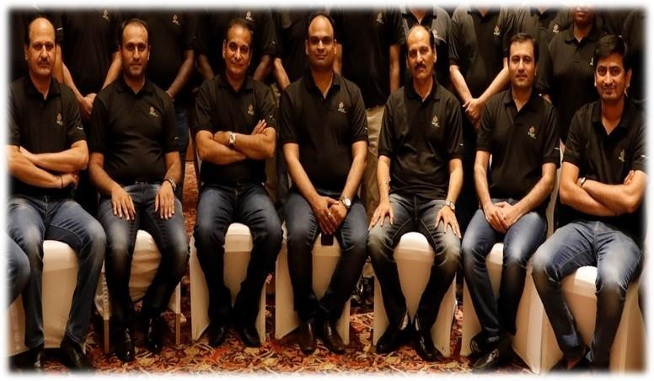



Ishwar Chand Mangal – Board Member & Executive Chairman

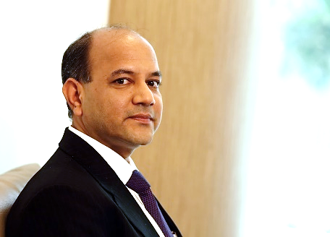

Mr. Ishwar Chand Mangal is a visionary leader and a highly respected professional in India's renewable energy sector, with nearly three decades of impactful contributions. He has played a pivotal role in the growth of India's wind energy sector, scaling it from megawatts (MW) to gigawatts (GW). As one of the pioneers of renewable energy in India in the early 1990s, he worked tirelessly to shape a conducive policy framework and business model that attracts business participation, and delivers end-to-end sustainable solution. His efforts were instrumental in laying the foundation for the rapid expansion of renewable energy in the country.

Mr. Mangal's leadership continues to inspire and mentor numerous renewable energy professionals, driving them to contribute towards the industry's mission of a greener and sustainable future. His career trajectory has seen great success, and now, as the Board Member and Executive Chairman of Enrich Energy Pvt. Ltd., he is leading the company's growth with a customer-centric approach.

His vision for Enrich and the broader renewable energy sector, is to help businesses reduce their carbon footprint and support the nations in meeting their Net-Zero goals. Through his work, he is committed to fostering sustainable development across the globe and making a meaningful impact on the planet for future generation.

Mr. Ishwar Chand Mangal did his bachelor’s in Mechanical Engineering from the Pune University in 1992 and later completed post-graduation in Import - Export Management. Before joining Enrich group, he was a pillar member at the leadership position with the wind energy major Suzlon for 29 years. He joined the Suzlon Group as one of the founder employee in 1996 and contributed significantly towards the growth of the company and the wind power market in India. He has witnessed and actively contributed to the growth of Wind Energy sector in India from less than a GW size to today’s more than 47 GW. During this tenure he held leadership position across different verticals from Sales & Marketing to Business Development, Projects and OTC (Order-To-Cash), Global Operations & Maintenance and the New Business Initiatives including Offshore Wind.

Mr. Ishwar Chand Mangal is a family man with an orientation towards spirituality, takes pride in Indian heritage and believes in being connected with one’s roots.

#### Ankit Kanchal – Founder & Managing Director

Ankit Kanchal is a professional turned founder, when he took the raw idea and turned into a company dedicated to Renewables. Academically, he holds a Degree in Finance and a Masters in Marketing. His 14 years of experience has largely been in the field of Renewables. Before becoming the anchor at Enrich, he was associated with Renewables major in India. To his credit are several national and international accolades that commend his contribution to the solar energy industry, these include – the Udyog Rattan Award, the Bharat Udyog Samman Puraskar and the Asia Pacific Achievers Award.



At the helm of the organization, he nurtures, leads, and inspires Team Enrich to overcome hurdles that come when an organization that has been growing at 50% CAGR and more recently at over 100% on a year to year basis. Through his strategic thinking, keen entrepreneurial acumen and depth of industry understanding as a pioneer, he sets the organization’s long term goals. He oversees global Business Development, Strategy and Planning, Corporate Finance, Legal, Human Resources and Administration. He also spearheads the organization’s foray into new businesses and adoption of world-class business practices that make Enrich “A great place to work”.

#### Arun Tripathi –Director & CEO – Renewables

#### 

Mr. Arun Tripathi has profound expertise in Solar, Wind, Hybrid, Energy Storage and other aspects of renewable energy. He carries with him more than 28 years of professional experience in renewable energy. In his career span, Mr. Tripathi was instrumental in winning over 2.6 GW bids in Solar, Wind and BESS. He has been the Chair to FICCI’s Taskforce on Energy Storage



At the helm of the organization, Mr. Tripathi leads, and inspires Team Enrich to overcome hurdles that come when an organization that has been growing at 50% CAGR and more recently at over 100% on a year to year basis. Through his strategic thinking, keen entrepreneurial acumen and depth of industry understanding as a pioneer, he sets the organization’s long term goals. He oversees global Business Development, Strategy and Planning, Corporate Finance, Legal, Human Resources and Administration. He also spearheads the organization’s foray into new businesses and adoption of world-class business practices that make Enrich “A great place to work”.

#### Dharmesh Tanti – Director Operations

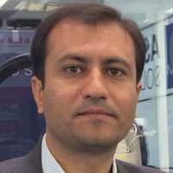

Dharmesh Tanti is an astute thinker and deeply passionate about Science & Technology, often pushing technology to evolve into more efficient next generation systems. As a founder at Enrich, he has been the pillar of strength in Technology development and Operational practices. Through his 17 years of experience in field of Renewables and energy efficiency, as well as a commonsensical approach, he has developed some path breaking concepts which have been adopted by the industry as best practices.

He oversees all technical aspects and develops the technological vision that enables Enrich to maintain its leadership position. He believes that true leadership is about listening to stakeholders, being open to fresh ideas, and engaging in an honest dialogue, to crystallize the real need for change, and then leading the change from the front. He also champions Quality management and safe practices, Quality analysis, and innovation in Project execution for improved competitiveness. He is currently working on an off/on grid energy storage solution and EV infrastructure for India. His next plans are adoption of CSP for India and to contribute towards research in newer Renewable technologies that are edging towards commercial viability in the coming decade.

#### About Enrich

[Promoters](https://enrichenergy.com/promoters)

#### Projects

[View All Projects](https://enrichenergy.com/projects)

#### Business Solutions

[EPC Solutions](https://enrichenergy.com/business_offerings/epc-solutions/)

[Clientele](https://enrichenergy.com/clientele) [(https://enrichenergy.com/clientele)](https://enrichenergy.com/clientele)

[(https://enrichenergy.com/promoters)](https://enrichenergy.com/promoters)

[Achievement](https://enrichenergy.com/achievements)

[(https://enrichenergy.com/projects)](https://enrichenergy.com/projects)

[End to End](https://enrichenergy.com/projects/#home)

[(https://enrichenergy.com/business_offerings](https://enrichenergy.com/business_offerings/epc-solutions/)M[/ep](https://enrichenergy.com/business_offerings/epc-solutions/)[e](https://enrichenergy.com/video)[c-](https://enrichenergy.com/business_offerings/epc-solutions/)[dia Center](https://enrichenergy.com/video)

[solutions/)](https://enrichenergy.com/business_offerings/epc-solutions/)

[(https://enrichenergy.com/achievements)](https://enrichenergy.com/achievements)

[(https://enrichenergy.com/projects/#home)](https://enrichenergy.com/projects/#home)

[End to End Solutions](https://enrichenergy.com/business_offerings/end-to-end-solutions)

[(https://enrichenergy.com/video)](https://enrichenergy.com/video)

[CSR](https://enrichenergy.com/csr) [(https://enrichenergy.com/csr)](https://enrichenergy.com/csr)

[EPC](https://enrichenergy.com/projects/#menu1)

[(https://enrichenergy.com/business_offerings](https://enrichenergy.com/business_offerings/end-to-end-solutions)B[/en](https://enrichenergy.com/business_offerings/end-to-end-solutions)[lo](https://enrichenergy.com/blogs)[d-](https://enrichenergy.com/business_offerings/end-to-end-solutions)[g](https://enrichenergy.com/blogs)

[Brochures](https://enrichenergy.com/wp-content/uploads/2017/12/Enrich-Energy_Corp-Brochure_2017.pdf)

[(https://enrichenergy.com/projects/#menu1)](https://enrichenergy.com/projects/#menu1) [to-end-solutions)](https://enrichenergy.com/business_offerings/end-to-end-solutions)

[(https://enrichenergy.com/wp-](https://enrichenergy.com/wp-content/uploads/2017/12/Enrich-Energy_Corp-Brochure_2017.pdf)

[IPP](https://enrichenergy.com/projects/#menu2)

[Rooftop Solutions](https://enrichenergy.com/business_offerings/rooftop-solutions/)

[(https://enrichenergy.com/blogs)](https://enrichenergy.com/blogs)

[content/uploads/2017/12/Enrich-](https://enrichenergy.com/wp-content/uploads/2017/12/Enrich-Energy_Corp-Brochure_2017.pdf)

[(https://enrichenergy.com/projects/#menu2)](https://enrichenergy.com/projects/#menu2) [(https://enrichenergy.com/business_offerings/rooftop-](https://enrichenergy.com/business_offerings/rooftop-solutions/)

[Energy_Corp-Brochure_2017.pdf)](https://enrichenergy.com/wp-content/uploads/2017/12/Enrich-Energy_Corp-Brochure_2017.pdf)

[Rooftop](https://enrichenergy.com/projects/#menu3)

[solutions/)](https://enrichenergy.com/business_offerings/rooftop-solutions/)

#### [Careers](https://enrichenergy.com/career)

[(https://enrichenergy.com/projects/#menu3)](https://enrichenergy.com/projects/#menu3) [O & M Services](https://enrichenergy.com/business_offerings/om-services/)



[(https://enrichenergy.com/career)](https://enrichenergy.com/career)

[(https://www.linkedin.com/company/9316416/)](https://www.linkedin.com/company/9316416/)

[(https://enrichenergy.com/business_offerings/om-](https://enrichenergy.com/business_offerings/om-services/) [services/)](https://enrichenergy.com/business_offerings/om-services/)

[Energy Storage](https://enrichenergy.com/business_offerings/energystorage/) [(https://enrichenergy.com/business_offerings/energystorage/)](https://enrichenergy.com/business_offerings/energystorage/) [Value Added Services](https://enrichenergy.com/business_offerings/value-added-services/) [(https://enrichenergy.com/business_offerings/value-](https://enrichenergy.com/business_offerings/value-added-services/)

[added-services/)](https://enrichenergy.com/business_offerings/value-added-services/)

[Privacy Policy (https://enrichenergy.com/privacy-policy/)](https://enrichenergy.com/privacy-policy/) [Disclaimer (https://enrichenergy.com/disclaimer)](https://enrichenergy.com/disclaimer) [Reach Us (https://enrichenergy.com/contact-us)](https://enrichenergy.com/contact-us)

[Copyright 2018](https://enrichenergy.com/copyright) [(https://enrichenergy.com/copyright)](https://enrichenergy.com/copyright), Enrich Energy Pvt. Ltd.

**REACH US**

# Achievements

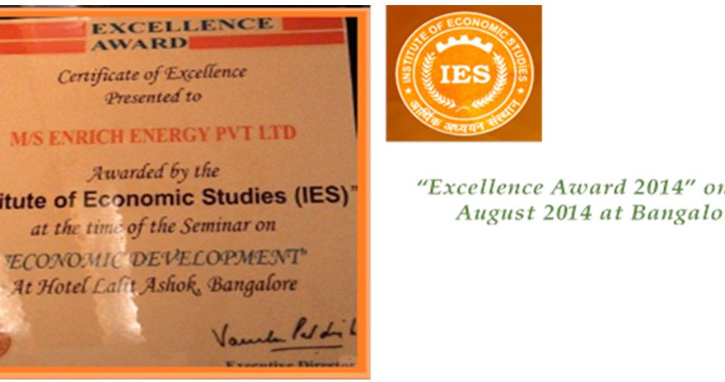

#### Excellence Award 2014’ on 13th August 2014 at Bangalore

About Enrich

[Promoters](https://enrichenergy.com/promoters)

#### Projects

[View All Projects](https://enrichenergy.com/projects)

#### Business Solutions

[EPC Solutions](https://enrichenergy.com/business_offerings/epc-solutions/)

[Clientele](https://enrichenergy.com/clientele) [(https://enrichenergy.com/clientele)](https://enrichenergy.com/clientele)

[(https://enrichenergy.com/promoters)](https://enrichenergy.com/promoters)

[Achievement](https://enrichenergy.com/achievements)

[(https://enrichenergy.com/projects)](https://enrichenergy.com/projects)

[End to End](https://enrichenergy.com/projects/#home)

[(https://enrichenergy.com/business_offerings](https://enrichenergy.com/business_offerings/epc-solutions/)M[/ep](https://enrichenergy.com/business_offerings/epc-solutions/)[e](https://enrichenergy.com/video)[c-](https://enrichenergy.com/business_offerings/epc-solutions/)[dia Center](https://enrichenergy.com/video)

[solutions/)](https://enrichenergy.com/business_offerings/epc-solutions/)

[(https://enrichenergy.com/achievements)](https://enrichenergy.com/achievements)

[(https://enrichenergy.com/projects/#home)](https://enrichenergy.com/projects/#home)

[End to End Solutions](https://enrichenergy.com/business_offerings/end-to-end-solutions)

[(https://enrichenergy.com/video)](https://enrichenergy.com/video)

[CSR](https://enrichenergy.com/csr) [(https://enrichenergy.com/csr)](https://enrichenergy.com/csr)

[EPC](https://enrichenergy.com/projects/#menu1)

[(https://enrichenergy.com/business_offerings](https://enrichenergy.com/business_offerings/end-to-end-solutions)B[/en](https://enrichenergy.com/business_offerings/end-to-end-solutions)[lo](https://enrichenergy.com/blogs)[d-](https://enrichenergy.com/business_offerings/end-to-end-solutions)[g](https://enrichenergy.com/blogs)

[Brochures](https://enrichenergy.com/wp-content/uploads/2017/12/Enrich-Energy_Corp-Brochure_2017.pdf)

[(https://enrichenergy.com/projects/#menu1)](https://enrichenergy.com/projects/#menu1) [to-end-solutions)](https://enrichenergy.com/business_offerings/end-to-end-solutions)

[(https://enrichenergy.com/wp-](https://enrichenergy.com/wp-content/uploads/2017/12/Enrich-Energy_Corp-Brochure_2017.pdf)

[IPP](https://enrichenergy.com/projects/#menu2)

[Rooftop Solutions](https://enrichenergy.com/business_offerings/rooftop-solutions/)

[(https://enrichenergy.com/blogs)](https://enrichenergy.com/blogs)

[content/uploads/2017/12/Enrich-](https://enrichenergy.com/wp-content/uploads/2017/12/Enrich-Energy_Corp-Brochure_2017.pdf)

[(https://enrichenergy.com/projects/#menu2)](https://enrichenergy.com/projects/#menu2) [(https://enrichenergy.com/business_offerings/rooftop-](https://enrichenergy.com/business_offerings/rooftop-solutions/)

[Energy_Corp-Brochure_2017.pdf)](https://enrichenergy.com/wp-content/uploads/2017/12/Enrich-Energy_Corp-Brochure_2017.pdf)

[Rooftop](https://enrichenergy.com/projects/#menu3)

[solutions/)](https://enrichenergy.com/business_offerings/rooftop-solutions/)

#### [Careers](https://enrichenergy.com/career)

[(https://enrichenergy.com/projects/#menu3)](https://enrichenergy.com/projects/#menu3) [O & M Services](https://enrichenergy.com/business_offerings/om-services/)



[(https://enrichenergy.com/career)](https://enrichenergy.com/career)

[(https://www.linkedin.com/company/9316416/)](https://www.linkedin.com/company/9316416/)

[(https://enrichenergy.com/business_offerings/om-](https://enrichenergy.com/business_offerings/om-services/) [services/)](https://enrichenergy.com/business_offerings/om-services/)

[Energy Storage](https://enrichenergy.com/business_offerings/energystorage/) [(https://enrichenergy.com/business_offerings/energystorage/)](https://enrichenergy.com/business_offerings/energystorage/) [Value Added Services](https://enrichenergy.com/business_offerings/value-added-services/) [(https://enrichenergy.com/business_offerings/value-](https://enrichenergy.com/business_offerings/value-added-services/)

[added-services/)](https://enrichenergy.com/business_offerings/value-added-services/)

[Privacy Policy (https://enrichenergy.com/privacy-policy/)](https://enrichenergy.com/privacy-policy/) [Disclaimer (https://enrichenergy.com/disclaimer)](https://enrichenergy.com/disclaimer) [Reach Us (https://enrichenergy.com/contact-us)](https://enrichenergy.com/contact-us)

[Copyright 2018](https://enrichenergy.com/copyright) [(https://enrichenergy.com/copyright)](https://enrichenergy.com/copyright), Enrich Energy Pvt. Ltd.

**REACH US**

# CSR

“Providing a Sustainable Source of Energy with competitive cost of ownership” as its founding principle, we at Enrich believe that sustainable growth can not only happen through economic prosperity, but it should also be balanced by Social and Environmental prosperity.

Enrich leads CSR, and is an integral part of commitment towards the social responsibility and giving back to the society. CSR is defined more like a “Responsible Business” practice rather than a charitable act. Currently, Enrich through its CSR initiatives works across all business verticals and all project sites.

Some of the examples of Enrich’s CSR initiatives:

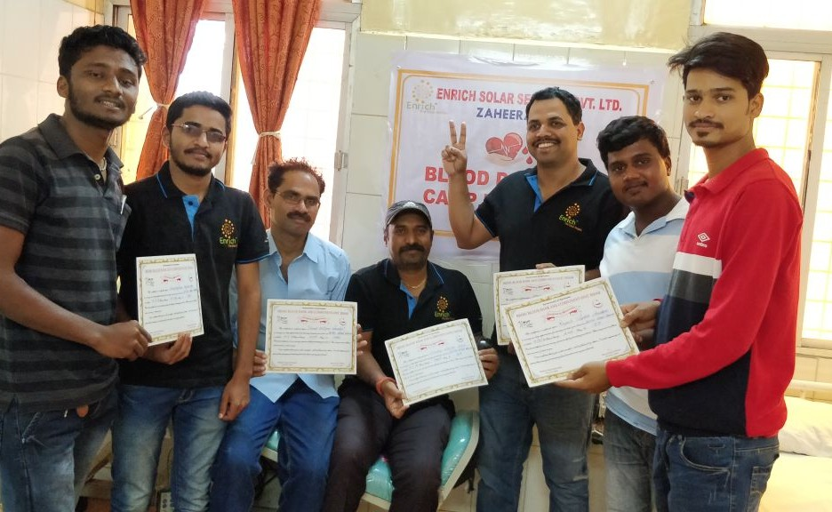

#### Blood Donation at Zaheerabad, Mandrup& Karajagi on 7th May,2018

About Enrich

[Promoters](https://enrichenergy.com/promoters)

#### Projects

[View All Projects](https://enrichenergy.com/projects)

#### Business Solutions

[EPC Solutions](https://enrichenergy.com/business_offerings/epc-solutions/)

[Clientele](https://enrichenergy.com/clientele) [(https://enrichenergy.com/clientele)](https://enrichenergy.com/clientele)

[(https://enrichenergy.com/promoters)](https://enrichenergy.com/promoters)

[Achievement](https://enrichenergy.com/achievements)

[(https://enrichenergy.com/projects)](https://enrichenergy.com/projects)

[End to End](https://enrichenergy.com/projects/#home)

[(https://enrichenergy.com/business_offerings](https://enrichenergy.com/business_offerings/epc-solutions/)M[/ep](https://enrichenergy.com/business_offerings/epc-solutions/)[e](https://enrichenergy.com/video)[c-](https://enrichenergy.com/business_offerings/epc-solutions/)[dia Center](https://enrichenergy.com/video)

[solutions/)](https://enrichenergy.com/business_offerings/epc-solutions/)

[(https://enrichenergy.com/achievements)](https://enrichenergy.com/achievements)

[(https://enrichenergy.com/projects/#home)](https://enrichenergy.com/projects/#home)

[End to End Solutions](https://enrichenergy.com/business_offerings/end-to-end-solutions)

[(https://enrichenergy.com/video)](https://enrichenergy.com/video)

[CSR](https://enrichenergy.com/csr) [(https://enrichenergy.com/csr)](https://enrichenergy.com/csr)

[EPC](https://enrichenergy.com/projects/#menu1)

[(https://enrichenergy.com/business_offerings](https://enrichenergy.com/business_offerings/end-to-end-solutions)B[/en](https://enrichenergy.com/business_offerings/end-to-end-solutions)[lo](https://enrichenergy.com/blogs)[d-](https://enrichenergy.com/business_offerings/end-to-end-solutions)[g](https://enrichenergy.com/blogs)

[Brochures](https://enrichenergy.com/wp-content/uploads/2017/12/Enrich-Energy_Corp-Brochure_2017.pdf)

[(https://enrichenergy.com/projects/#menu1)](https://enrichenergy.com/projects/#menu1) [to-end-solutions)](https://enrichenergy.com/business_offerings/end-to-end-solutions)

[(https://enrichenergy.com/wp-](https://enrichenergy.com/wp-content/uploads/2017/12/Enrich-Energy_Corp-Brochure_2017.pdf)

[IPP](https://enrichenergy.com/projects/#menu2)

[Rooftop Solutions](https://enrichenergy.com/business_offerings/rooftop-solutions/)

[(https://enrichenergy.com/blogs)](https://enrichenergy.com/blogs)

[content/uploads/2017/12/Enrich-](https://enrichenergy.com/wp-content/uploads/2017/12/Enrich-Energy_Corp-Brochure_2017.pdf)

[(https://enrichenergy.com/projects/#menu2)](https://enrichenergy.com/projects/#menu2) [(https://enrichenergy.com/business_offerings/rooftop-](https://enrichenergy.com/business_offerings/rooftop-solutions/)

[Energy_Corp-Brochure_2017.pdf)](https://enrichenergy.com/wp-content/uploads/2017/12/Enrich-Energy_Corp-Brochure_2017.pdf)

[Rooftop](https://enrichenergy.com/projects/#menu3)

[solutions/)](https://enrichenergy.com/business_offerings/rooftop-solutions/)

#### [Careers](https://enrichenergy.com/career)

[(https://enrichenergy.com/projects/#menu3)](https://enrichenergy.com/projects/#menu3) [O & M Services](https://enrichenergy.com/business_offerings/om-services/)



[(https://enrichenergy.com/career)](https://enrichenergy.com/career)

[(https://www.linkedin.com/company/9316416/)](https://www.linkedin.com/company/9316416/)

[(https://enrichenergy.com/business_offerings/om-](https://enrichenergy.com/business_offerings/om-services/) [services/)](https://enrichenergy.com/business_offerings/om-services/)

[Energy Storage](https://enrichenergy.com/business_offerings/energystorage/) [(https://enrichenergy.com/business_offerings/energystorage/)](https://enrichenergy.com/business_offerings/energystorage/) [Value Added Services](https://enrichenergy.com/business_offerings/value-added-services/) [(https://enrichenergy.com/business_offerings/value-](https://enrichenergy.com/business_offerings/value-added-services/)

[added-services/)](https://enrichenergy.com/business_offerings/value-added-services/)

[Privacy Policy (https://enrichenergy.com/privacy-policy/)](https://enrichenergy.com/privacy-policy/) [Disclaimer (https://enrichenergy.com/disclaimer)](https://enrichenergy.com/disclaimer) [Reach Us (https://enrichenergy.com/contact-us)](https://enrichenergy.com/contact-us)

[Copyright 2018](https://enrichenergy.com/copyright) [(https://enrichenergy.com/copyright)](https://enrichenergy.com/copyright), Enrich Energy Pvt. Ltd.

**REACH US**

# Vision, Values and IMS Policy

Life at Enrich is based on the Vision that drives, the values that guide, and a culture that enables.

## Vision

We endeavour to be a world class organization in renewable energy sector and play a pivotal role in contributing to the energy growth requirements with sustainable and eco-friendly solutions and be a Company of Choice for all stakeholders.

## Our Values

Integrity, Ownership, Innovation, Agility, Performance driven.

## Integrated Management System (IMS) Policy

#### Quality, Occupational Health & Safety, Environment

The various stakeholders of ENRICH have different context of interest, needs and expectations. As a responsible Organization, ENRICH seeks to fulfil its obligations towards its various stakeholders through continual improvement and by defining Quality, Occupational Health & Safety and Environmental objectives.

ENRICH commits to provide quality products and services to the customer and shall strive to achieve customer satisfaction with due fulfilment of statutory and regulatory requirements.

ENRICH is committed to fulfilment of applicable legal and other requirements related to occupational health & safety hazards and prevention of injury and ill health to all working under the control of the Organization.

ENRICH is committed to protection of environment, prevention of pollution and fulfilment of its compliance obligations for sustainable development.

ENRICH endeavours to attain a high level of adherence to the IMS requirements through development of skilled & motivated manpower and participation of stakeholders.

#### About Enrich

[Promoters](https://enrichenergy.com/promoters)

#### Projects

[View All Projects](https://enrichenergy.com/projects)

#### Business Solutions

[EPC Solutions](https://enrichenergy.com/business_offerings/epc-solutions/)

[Clientele](https://enrichenergy.com/clientele) [(https://enrichenergy.com/clientele)](https://enrichenergy.com/clientele)

[(https://enrichenergy.com/promoters)](https://enrichenergy.com/promoters)

[Achievement](https://enrichenergy.com/achievements)

[(https://enrichenergy.com/projects)](https://enrichenergy.com/projects)

[End to End](https://enrichenergy.com/projects/#home)

[(https://enrichenergy.com/business_offerings](https://enrichenergy.com/business_offerings/epc-solutions/)M[/ep](https://enrichenergy.com/business_offerings/epc-solutions/)[e](https://enrichenergy.com/video)[c-](https://enrichenergy.com/business_offerings/epc-solutions/)[dia Center](https://enrichenergy.com/video)

[solutions/)](https://enrichenergy.com/business_offerings/epc-solutions/)

[(https://enrichenergy.com/achievements)](https://enrichenergy.com/achievements)

[(https://enrichenergy.com/projects/#home)](https://enrichenergy.com/projects/#home)

[End to End Solutions](https://enrichenergy.com/business_offerings/end-to-end-solutions)

[(https://enrichenergy.com/video)](https://enrichenergy.com/video)

[CSR](https://enrichenergy.com/csr) [(https://enrichenergy.com/csr)](https://enrichenergy.com/csr)

[EPC](https://enrichenergy.com/projects/#menu1)

[(https://enrichenergy.com/business_offerings](https://enrichenergy.com/business_offerings/end-to-end-solutions)B[/en](https://enrichenergy.com/business_offerings/end-to-end-solutions)[lo](https://enrichenergy.com/blogs)[d-](https://enrichenergy.com/business_offerings/end-to-end-solutions)[g](https://enrichenergy.com/blogs)

[Brochures](https://enrichenergy.com/wp-content/uploads/2017/12/Enrich-Energy_Corp-Brochure_2017.pdf)

[(https://enrichenergy.com/projects/#menu1)](https://enrichenergy.com/projects/#menu1) [to-end-solutions)](https://enrichenergy.com/business_offerings/end-to-end-solutions)

[(https://enrichenergy.com/wp-](https://enrichenergy.com/wp-content/uploads/2017/12/Enrich-Energy_Corp-Brochure_2017.pdf)

[IPP](https://enrichenergy.com/projects/#menu2)

[Rooftop Solutions](https://enrichenergy.com/business_offerings/rooftop-solutions/)

[(https://enrichenergy.com/blogs)](https://enrichenergy.com/blogs)

[content/uploads/2017/12/Enrich-](https://enrichenergy.com/wp-content/uploads/2017/12/Enrich-Energy_Corp-Brochure_2017.pdf)

[(https://enrichenergy.com/projects/#menu2)](https://enrichenergy.com/projects/#menu2) [(https://enrichenergy.com/business_offerings/rooftop-](https://enrichenergy.com/business_offerings/rooftop-solutions/)

[Energy_Corp-Brochure_2017.pdf)](https://enrichenergy.com/wp-content/uploads/2017/12/Enrich-Energy_Corp-Brochure_2017.pdf)

[Rooftop](https://enrichenergy.com/projects/#menu3)

[solutions/)](https://enrichenergy.com/business_offerings/rooftop-solutions/)

#### [Careers](https://enrichenergy.com/career)

[(https://enrichenergy.com/projects/#menu3)](https://enrichenergy.com/projects/#menu3) [O & M Services](https://enrichenergy.com/business_offerings/om-services/)



[(https://enrichenergy.com/career)](https://enrichenergy.com/career)

[(https://www.linkedin.com/company/9316416/)](https://www.linkedin.com/company/9316416/)

[(https://enrichenergy.com/business_offerings/om-](https://enrichenergy.com/business_offerings/om-services/) [services/)](https://enrichenergy.com/business_offerings/om-services/)

[Energy Storage](https://enrichenergy.com/business_offerings/energystorage/) [(https://enrichenergy.com/business_offerings/energystorage/)](https://enrichenergy.com/business_offerings/energystorage/) [Value Added Services](https://enrichenergy.com/business_offerings/value-added-services/) [(https://enrichenergy.com/business_offerings/value-](https://enrichenergy.com/business_offerings/value-added-services/)

[added-services/)](https://enrichenergy.com/business_offerings/value-added-services/)

[Privacy Policy (https://enrichenergy.com/privacy-policy/)](https://enrichenergy.com/privacy-policy/) [Disclaimer (https://enrichenergy.com/disclaimer)](https://enrichenergy.com/disclaimer) [Reach Us (https://enrichenergy.com/contact-us)](https://enrichenergy.com/contact-us)

[Copyright 2018](https://enrichenergy.com/copyright) [(https://enrichenergy.com/copyright)](https://enrichenergy.com/copyright), Enrich Energy Pvt. Ltd.

# Projects

All

End to End

EPC

IPP

Rooftop

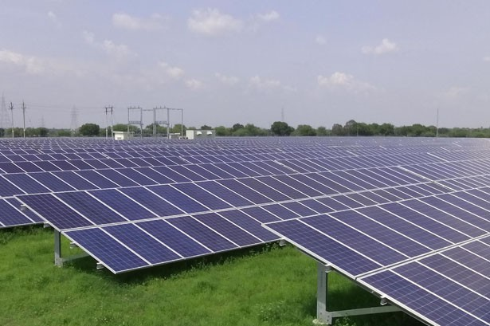

**[50 MW](https://enrichenergy.com/project/solar-park-mandrup/)**

[Solar Park Mandrup, Maharashtra](https://enrichenergy.com/project/solar-park-mandrup/)

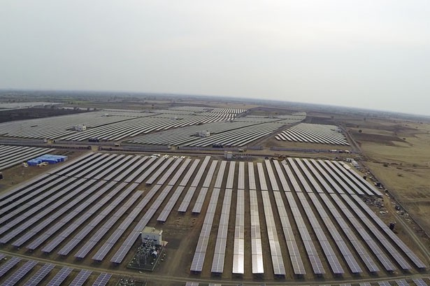

[**100 MW**](https://enrichenergy.com/project/100-mw-solar-park-zaheerabad/)

[Solar Park Zaheerabad, Telangana](https://enrichenergy.com/project/100-mw-solar-park-zaheerabad/)

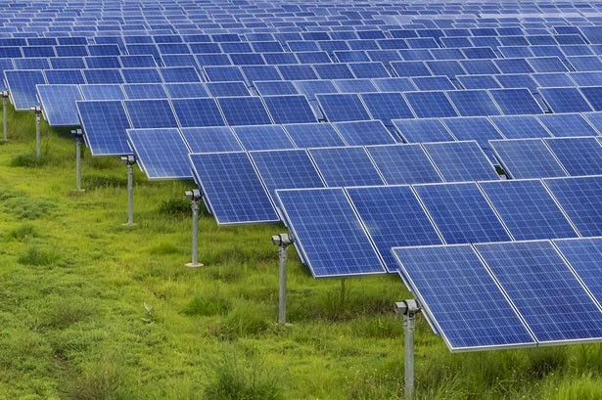

[**50 MW**](https://enrichenergy.com/project/50-mw-solar-park-karajagi/)

[Solar Park Karajagi, Maharashtra](https://enrichenergy.com/project/50-mw-solar-park-karajagi/)

[(https://enrichenergy.com/project/solar-park-](https://enrichenergy.com/project/solar-park-mandrup/) [mandrup/)](https://enrichenergy.com/project/solar-park-mandrup/)

**REACH US**

[(https://enrichenergy .com/project/100-mw-](https://enrichenergy.com/project/100-mw-solar-park-zaheerabad/) [solar-park-zaheerabad/)](https://enrichenergy.com/project/100-mw-solar-park-zaheerabad/)

[(https://enrichenergy.com/project/50-mw-solar-](https://enrichenergy.com/project/50-mw-solar-park-karajagi/) [park-karajagi/)](https://enrichenergy.com/project/50-mw-solar-park-karajagi/)

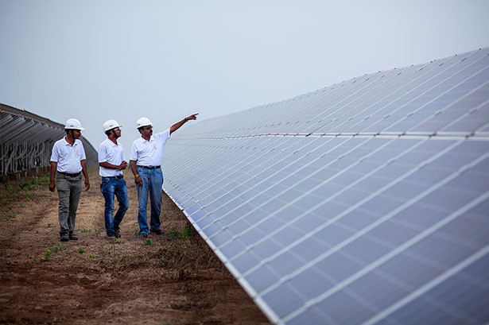

[**10 MW**](https://enrichenergy.com/project/warangal-telangana/)

[Warangal, Telangana](https://enrichenergy.com/project/warangal-telangana/)

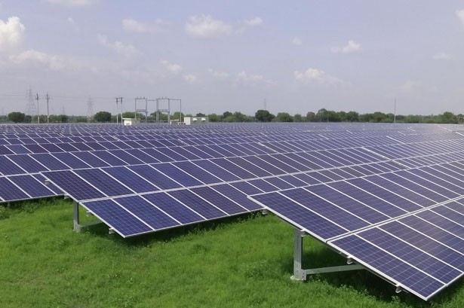

[**5 MW**](https://enrichenergy.com/project/5-mw-mahoba-uttar-pradesh/)

[Mahoba, Uttar Pradesh](https://enrichenergy.com/project/5-mw-mahoba-uttar-pradesh/)

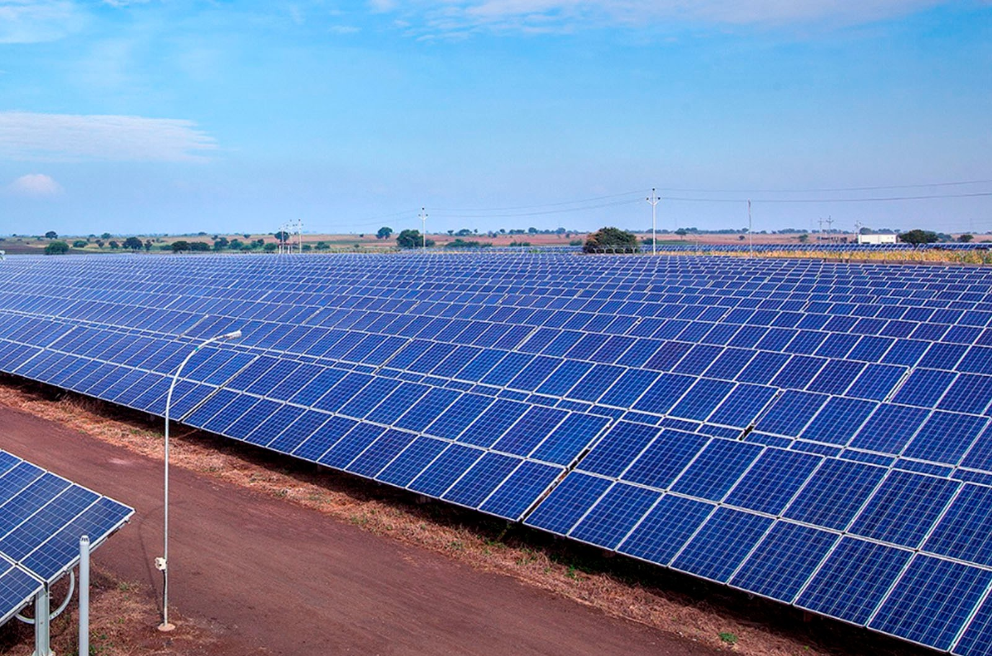

[**15 MW**](https://enrichenergy.com/project/15-mw-nalgonda-telangana/)

[Nalgonda, Telangana](https://enrichenergy.com/project/15-mw-nalgonda-telangana/)

[(https://enrichenergy.com/project/warangal-](https://enrichenergy.com/project/warangal-telangana/) [telangana/)](https://enrichenergy.com/project/warangal-telangana/)

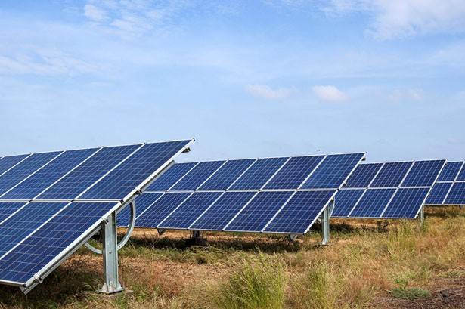

[**3 MW**](https://enrichenergy.com/project/3-mw-bellary-karnataka/)

[Bellary, Karnataka](https://enrichenergy.com/project/3-mw-bellary-karnataka/)

[(https://enrichenergy.com/project/5-mw-](https://enrichenergy.com/project/5-mw-mahoba-uttar-pradesh/) [mahoba-uttar-pradesh/)](https://enrichenergy.com/project/5-mw-mahoba-uttar-pradesh/)

[(https://enrichenergy.com/project/15-mw-](https://enrichenergy.com/project/15-mw-nalgonda-telangana/) [nalgonda-telangana/)](https://enrichenergy.com/project/15-mw-nalgonda-telangana/)

[(https://enrichenergy.com/project/3-mw-bellary-](https://enrichenergy.com/project/3-mw-bellary-karnataka/) [karnataka/)](https://enrichenergy.com/project/3-mw-bellary-karnataka/)

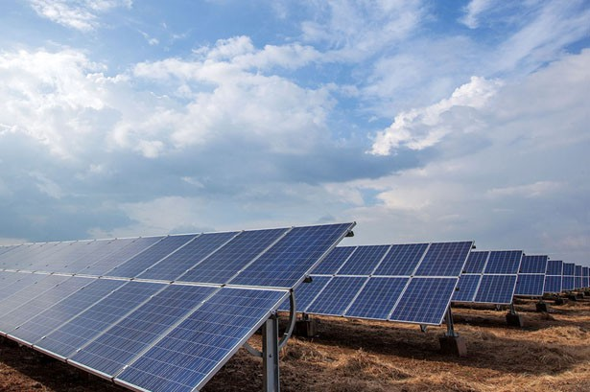

[**2 MW**](https://enrichenergy.com/project/2-mw-turmamidi-telangana/)

[Turmamidi, Telangana](https://enrichenergy.com/project/2-mw-turmamidi-telangana/)

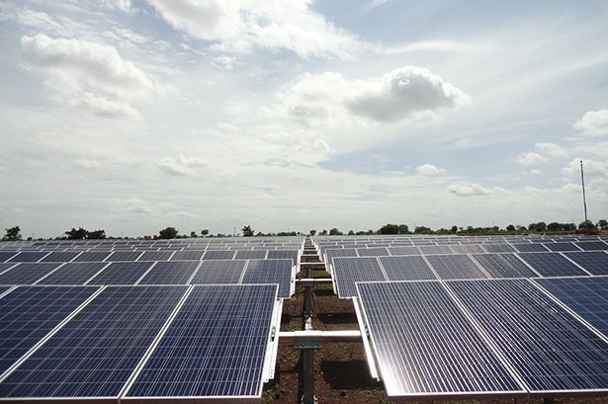

[**1 MW**](https://enrichenergy.com/project/mundargi-karnataka/)

[Mundargi, Karnataka](https://enrichenergy.com/project/mundargi-karnataka/)

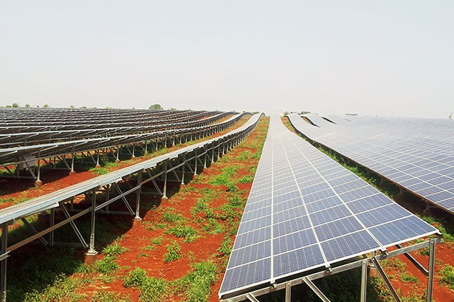

[**7 MW**](https://enrichenergy.com/project/turmamidi/)

[Turmamidi, Telangana](https://enrichenergy.com/project/turmamidi/)

[(https://enrichenergy.com/project/turmamidi/)](https://enrichenergy.com/project/turmamidi/)

[(https://enrichenergy.com/project/2-mw-](https://enrichenergy.com/project/2-mw-turmamidi-telangana/) [turmamidi-telangana/)](https://enrichenergy.com/project/2-mw-turmamidi-telangana/)

[(https://enrichenergy.com/project/mundargi-](https://enrichenergy.com/project/mundargi-karnataka/) [karnataka/)](https://enrichenergy.com/project/mundargi-karnataka/)

[(https://enrichenergy.com/project/zaheerabad/)](https://enrichenergy.com/project/zaheerabad/)

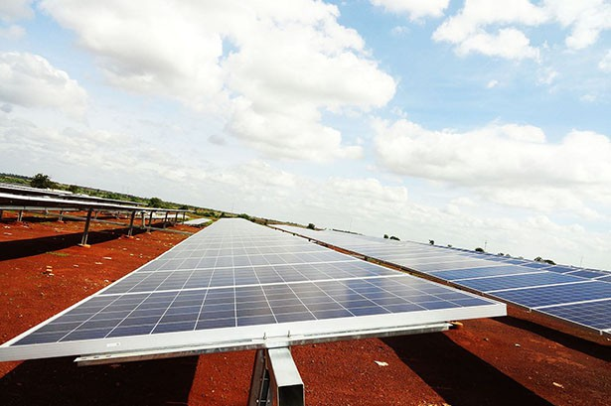

[**3 MW**](https://enrichenergy.com/project/bellary/)

[Bellary, Karnataka](https://enrichenergy.com/project/bellary/)

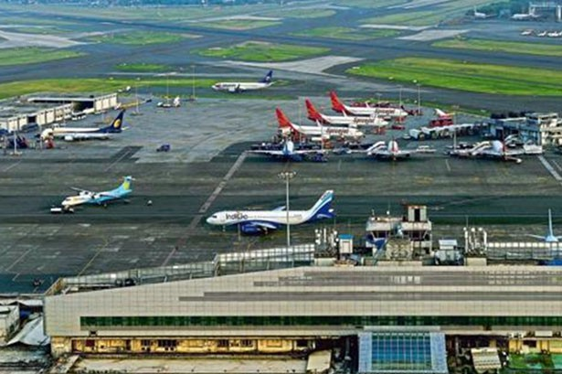

[**642 kWp**](https://enrichenergy.com/project/642-kw-mumbai-airport-mumbai-maharashtra/)

[Mumbai International Airport, Maharashtra](https://enrichenergy.com/project/642-kw-mumbai-airport-mumbai-maharashtra/)

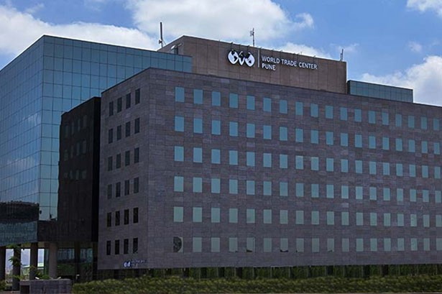

[**42 kWp**](https://enrichenergy.com/project/40-kw-world-trade-centre-pune-maharashtra/)

[World Trade Centre, Pune, Maharashtra](https://enrichenergy.com/project/40-kw-world-trade-centre-pune-maharashtra/)

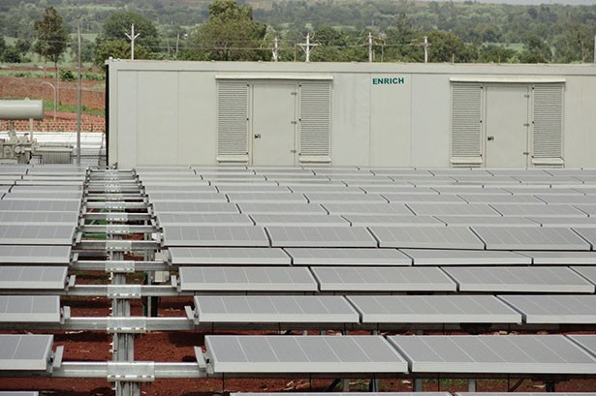

[**3 MW**](https://enrichenergy.com/project/zaheerabad/)

[Zaheerabad ,Telangana](https://enrichenergy.com/project/zaheerabad/)

[(https://enrichenergy.com/project/bellary/)](https://enrichenergy.com/project/bellary/) [(https://enrichenergy.com/project/642-kw-](https://enrichenergy.com/project/642-kw-mumbai-airport-mumbai-maharashtra/)

[mumbai-airport-mumbai-maharashtra/)](https://enrichenergy.com/project/642-kw-mumbai-airport-mumbai-maharashtra/)

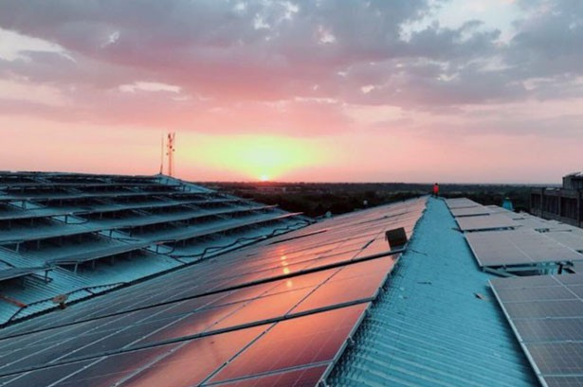

[**1745 kWp**](https://enrichenergy.com/project/sudiva-spinner-bhilwara-rajasthan/)

[Bhilwara, Rajasthan](https://enrichenergy.com/project/sudiva-spinner-bhilwara-rajasthan/)

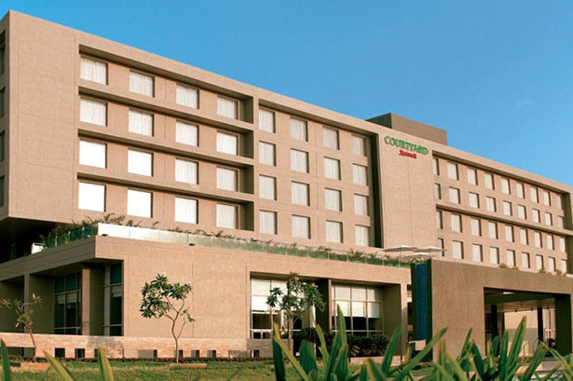

[**60 kWp**](https://enrichenergy.com/project/60-kw-hotel-courtyard-marriot-pune-maharashtra/)

[Hotel Courtyard Marriot, Pune, Maharashtra](https://enrichenergy.com/project/60-kw-hotel-courtyard-marriot-pune-maharashtra/)

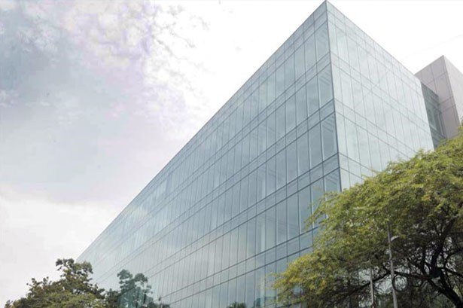

[**81 kWp**](https://enrichenergy.com/project/80-kw-the-chambers-pune-maharashtra/)

[The Chambers, Pune, Maharashtra](https://enrichenergy.com/project/80-kw-the-chambers-pune-maharashtra/)

[(https://enrichenergy.com/project/40-kw-world-](https://enrichenergy.com/project/40-kw-world-trade-centre-pune-maharashtra/) [trade-centre-pune-maharashtra/)](https://enrichenergy.com/project/40-kw-world-trade-centre-pune-maharashtra/)

[(https://enrichenergy.com/project/sudiva-](https://enrichenergy.com/project/sudiva-spinner-bhilwara-rajasthan/) [spinner-bhilwara-rajasthan/)](https://enrichenergy.com/project/sudiva-spinner-bhilwara-rajasthan/)

[(https://enrichenergy.com/project/60-kw-hotel-](https://enrichenergy.com/project/60-kw-hotel-courtyard-marriot-pune-maharashtra/) [courtyard-marriot-pune-maharashtra/)](https://enrichenergy.com/project/60-kw-hotel-courtyard-marriot-pune-maharashtra/)

[(https://enrichenergy.com/project/80-kw-the-](https://enrichenergy.com/project/80-kw-the-chambers-pune-maharashtra/) [chambers-pune-maharashtra/)](https://enrichenergy.com/project/80-kw-the-chambers-pune-maharashtra/)

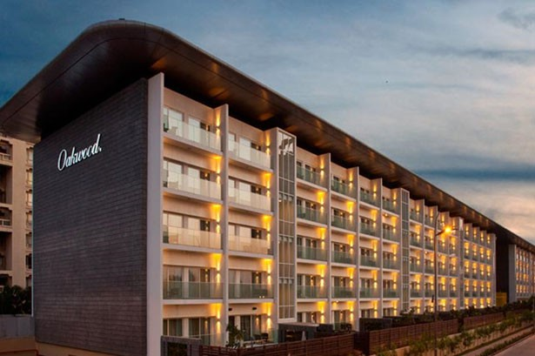

[**120 kWp**](https://enrichenergy.com/project/120-kw-oakwood-premier-pune-maharashtra/)

[Oakwood Premier, Pune, Maharashtra](https://enrichenergy.com/project/120-kw-oakwood-premier-pune-maharashtra/)

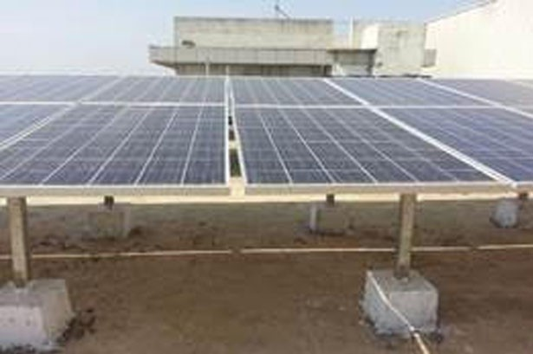

[**25 kWp**](https://enrichenergy.com/project/pudhari-corporate-office-kolhapur-maharashtra/)

[Kolhapur, Maharashtra](https://enrichenergy.com/project/pudhari-corporate-office-kolhapur-maharashtra/)

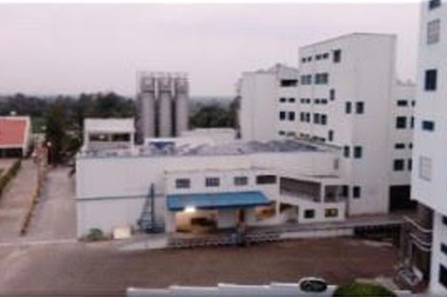

[**120 kWp**](https://enrichenergy.com/project/chitale-group-kolhapur-maharashtra/)

[Kolhapur, Maharashtra](https://enrichenergy.com/project/chitale-group-kolhapur-maharashtra/)

[(https://enrichenergy.com/project/120-kw-](https://enrichenergy.com/project/120-kw-oakwood-premier-pune-maharashtra/) [oakwood-premier-pune-maharashtra/)](https://enrichenergy.com/project/120-kw-oakwood-premier-pune-maharashtra/)

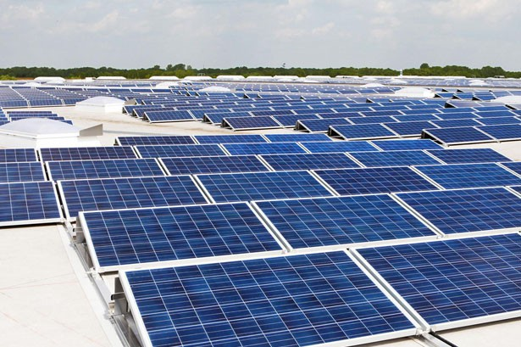

[**30 kWp**](https://enrichenergy.com/project/midc-shiroli-sangli-maharashtra/)

[MIDC Shiroli, Sangli, Maharashtra](https://enrichenergy.com/project/midc-shiroli-sangli-maharashtra/)

[(https://enrichenergy.com/project/pudhari-](https://enrichenergy.com/project/pudhari-corporate-office-kolhapur-maharashtra/) [corporate-office-kolhapur-maharashtra/)](https://enrichenergy.com/project/pudhari-corporate-office-kolhapur-maharashtra/)

[(https://enrichenergy.com/project/chitale-group-](https://enrichenergy.com/project/chitale-group-kolhapur-maharashtra/) [kolhapur-maharashtra/)](https://enrichenergy.com/project/chitale-group-kolhapur-maharashtra/)

[(https://enrichenergy.com/project/midc-shiroli-](https://enrichenergy.com/project/midc-shiroli-sangli-maharashtra/) [sangli-maharashtra/)](https://enrichenergy.com/project/midc-shiroli-sangli-maharashtra/)

#### About Enrich

[Promoters](https://enrichenergy.com/promoters)

#### Projects

[View All Projects](https://enrichenergy.com/projects)

#### Business Solutions

[EPC Solutions](https://enrichenergy.com/business_offerings/epc-solutions/)

[Clientele](https://enrichenergy.com/clientele) [(https://enrichenergy.com/clientele)](https://enrichenergy.com/clientele)

[(https://enrichenergy.com/promoters)](https://enrichenergy.com/promoters)

[Achievement](https://enrichenergy.com/achievements)

[(https://enrichenergy.com/projects)](https://enrichenergy.com/projects)

End to End

[(https://enrichenergy.com/business_offerings](https://enrichenergy.com/business_offerings/epc-solutions/)M[/ep](https://enrichenergy.com/business_offerings/epc-solutions/)[e](https://enrichenergy.com/video)[c-](https://enrichenergy.com/business_offerings/epc-solutions/)[dia Center](https://enrichenergy.com/video)

[solutions/)](https://enrichenergy.com/business_offerings/epc-solutions/)

[(https://enrichenergy.com/achievements)](https://enrichenergy.com/achievements)

(https://enrichenergy.com/projects/#home)

[End to End Solutions](https://enrichenergy.com/business_offerings/end-to-end-solutions)

[(https://enrichenergy.com/video)](https://enrichenergy.com/video)

[CSR](https://enrichenergy.com/csr) [(https://enrichenergy.com/csr)](https://enrichenergy.com/csr)

[(https://enrichenergy.com/business_offerings/end-](https://enrichenergy.com/business_offerings/end-to-end-solutions)

[Brochures](https://enrichenergy.com/wp-content/uploads/2017/12/Enrich-Energy_Corp-Brochure_2017.pdf)

EPC

[to-end-solutions)](https://enrichenergy.com/business_offerings/end-to-end-solutions)

#### [Blog](https://enrichenergy.com/blogs)

[(https://enrichenergy.com/wp-](https://enrichenergy.com/wp-content/uploads/2017/12/Enrich-Energy_Corp-Brochure_2017.pdf)

(https://enrichenergy.com/projects/#menu1) [Rooftop Solutions](https://enrichenergy.com/business_offerings/rooftop-solutions/)

[(https://enrichenergy.com/blogs)](https://enrichenergy.com/blogs)

[content/uploads/2017/12/Enrich-](https://enrichenergy.com/wp-content/uploads/2017/12/Enrich-Energy_Corp-Brochure_2017.pdf)

IPP

[(https://enrichenergy.com/business_offerings/rooftop-](https://enrichenergy.com/business_offerings/rooftop-solutions/)

[Energy_Corp-Brochure_2017.pdf)](https://enrichenergy.com/wp-content/uploads/2017/12/Enrich-Energy_Corp-Brochure_2017.pdf)

(https://enrichenergy.com/projects/#menu2) [solutions/)](https://enrichenergy.com/business_offerings/rooftop-solutions/)

#### [Careers](https://enrichenergy.com/career)

Rooftop



[O & M Services](https://enrichenergy.com/business_offerings/om-services/)

[(https://enrichenergy.com/career)](https://enrichenergy.com/career)

(https://enrichenergy.com/projects/#menu3) [(https://enrichenergy.com/business_offerings/om-](https://enrichenergy.com/business_offerings/om-services/)

[(https://www.linkedin.com/company/9316416/)](https://www.linkedin.com/company/9316416/)

[services/)](https://enrichenergy.com/business_offerings/om-services/)

[Energy Storage](https://enrichenergy.com/business_offerings/energystorage/) [(https://enrichenergy.com/business_offerings/energystorage/)](https://enrichenergy.com/business_offerings/energystorage/) [Value Added Services](https://enrichenergy.com/business_offerings/value-added-services/) [(https://enrichenergy.com/business_offerings/value-](https://enrichenergy.com/business_offerings/value-added-services/)

[added-services/)](https://enrichenergy.com/business_offerings/value-added-services/)

[Privacy Policy (https://enrichenergy.com/privacy-policy/)](https://enrichenergy.com/privacy-policy/) [Disclaimer (https://enrichenergy.com/disclaimer)](https://enrichenergy.com/disclaimer) [Reach Us (https://enrichenergy.com/contact-us)](https://enrichenergy.com/contact-us)

[Copyright 2018](https://enrichenergy.com/copyright) [(https://enrichenergy.com/copyright)](https://enrichenergy.com/copyright), Enrich Energy Pvt. Ltd.

**REACH US**

# Business Offerings

## EPC Solutions

Enrich’s EPC services ensure that your resources are optimized to their fullest. With clearly defined parameters from the Customer, we are equipped to handle any scale of solar projects from design development to turnkey EPC project.

Enrich dwells upon the finer nuances of each project, especially timely execution, Quality control and reducing minor complications that may arise on the field.

Enrich’s experienced and competent team provides suitable system design that adheres strictly to Customer brief. Quality components are key factors towards smooth functioning of the solar farm. We source the highest Quality components to harmonize with a superior design, to ensure optimum energy output and return on investment for our Customer.

The most important aspect of any project is its actual construction and development. Working in unison with your in-house professionals we work towards design realization. Enrich has the expertise and know – how to obtain necessary licenses, permissions and other government

documentation, ensuring rules and local codes are carefully maintained and that construction work is complete completed within the promised stipulated time frame.

#### About Enrich

[Promoters](https://enrichenergy.com/promoters)

#### Projects

[View All Projects](https://enrichenergy.com/projects)

#### Business Solutions

[EPC Solutions](https://enrichenergy.com/business_offerings/epc-solutions/)

[Clientele](https://enrichenergy.com/clientele) [(https://enrichenergy.com/clientele)](https://enrichenergy.com/clientele)

[(https://enrichenergy.com/promoters)](https://enrichenergy.com/promoters)

[Achievement](https://enrichenergy.com/achievements)

[(https://enrichenergy.com/projects)](https://enrichenergy.com/projects)

[End to End](https://enrichenergy.com/projects/#home)

[(https://enrichenergy.com/business_offerings](https://enrichenergy.com/business_offerings/epc-solutions/)M[/ep](https://enrichenergy.com/business_offerings/epc-solutions/)[e](https://enrichenergy.com/video)[c-](https://enrichenergy.com/business_offerings/epc-solutions/)[dia Center](https://enrichenergy.com/video)

[solutions/)](https://enrichenergy.com/business_offerings/epc-solutions/)

[(https://enrichenergy.com/achievements)](https://enrichenergy.com/achievements)

[(https://enrichenergy.com/projects/#home)](https://enrichenergy.com/projects/#home)

[End to End Solutions](https://enrichenergy.com/business_offerings/end-to-end-solutions)

[(https://enrichenergy.com/video)](https://enrichenergy.com/video)

[CSR](https://enrichenergy.com/csr) [(https://enrichenergy.com/csr)](https://enrichenergy.com/csr)

[EPC](https://enrichenergy.com/projects/#menu1)

[(https://enrichenergy.com/business_offerings](https://enrichenergy.com/business_offerings/end-to-end-solutions)B[/en](https://enrichenergy.com/business_offerings/end-to-end-solutions)[lo](https://enrichenergy.com/blogs)[d-](https://enrichenergy.com/business_offerings/end-to-end-solutions)[g](https://enrichenergy.com/blogs)

[Brochures](https://enrichenergy.com/wp-content/uploads/2017/12/Enrich-Energy_Corp-Brochure_2017.pdf)

[(https://enrichenergy.com/projects/#menu1)](https://enrichenergy.com/projects/#menu1) [to-end-solutions)](https://enrichenergy.com/business_offerings/end-to-end-solutions)

[(https://enrichenergy.com/wp-](https://enrichenergy.com/wp-content/uploads/2017/12/Enrich-Energy_Corp-Brochure_2017.pdf)

[IPP](https://enrichenergy.com/projects/#menu2)

[Rooftop Solutions](https://enrichenergy.com/business_offerings/rooftop-solutions/)

[(https://enrichenergy.com/blogs)](https://enrichenergy.com/blogs)

[content/uploads/2017/12/Enrich-](https://enrichenergy.com/wp-content/uploads/2017/12/Enrich-Energy_Corp-Brochure_2017.pdf)

[(https://enrichenergy.com/projects/#menu2)](https://enrichenergy.com/projects/#menu2) [(https://enrichenergy.com/business_offerings/rooftop-](https://enrichenergy.com/business_offerings/rooftop-solutions/)

[Energy_Corp-Brochure_2017.pdf)](https://enrichenergy.com/wp-content/uploads/2017/12/Enrich-Energy_Corp-Brochure_2017.pdf)

[Rooftop](https://enrichenergy.com/projects/#menu3)

[solutions/)](https://enrichenergy.com/business_offerings/rooftop-solutions/)

#### [Careers](https://enrichenergy.com/career)

[(https://enrichenergy.com/projects/#menu3)](https://enrichenergy.com/projects/#menu3) [O & M Services](https://enrichenergy.com/business_offerings/om-services/)



[(https://enrichenergy.com/career)](https://enrichenergy.com/career)

[(https://www.linkedin.com/company/9316416/)](https://www.linkedin.com/company/9316416/)

[(https://enrichenergy.com/business_offerings/om-](https://enrichenergy.com/business_offerings/om-services/) [services/)](https://enrichenergy.com/business_offerings/om-services/)

[Energy Storage](https://enrichenergy.com/business_offerings/energystorage/) [(https://enrichenergy.com/business_offerings/energystorage/)](https://enrichenergy.com/business_offerings/energystorage/) [Value Added Services](https://enrichenergy.com/business_offerings/value-added-services/) [(https://enrichenergy.com/business_offerings/value-](https://enrichenergy.com/business_offerings/value-added-services/)

[added-services/)](https://enrichenergy.com/business_offerings/value-added-services/)

[Privacy Policy (https://enrichenergy.com/privacy-policy/)](https://enrichenergy.com/privacy-policy/) [Disclaimer (https://enrichenergy.com/disclaimer)](https://enrichenergy.com/disclaimer) [Reach Us (https://enrichenergy.com/contact-us)](https://enrichenergy.com/contact-us)

[Copyright 2018](https://enrichenergy.com/copyright) [(https://enrichenergy.com/copyright)](https://enrichenergy.com/copyright), Enrich Energy Pvt. Ltd.

**REACH US**

# Business Offerings

## End to End Solutions

Enrich’s adaptable End to End solutions through self and its associate companies in solar photovoltaic (PV) energy solutions, enable Customers to generate clean and affordable energy, with low maintenance, tailored to the needs of the project and environment. Enrich manages complete Solar energy project from early stages of development to securing financing, approvals to bringing the project to fruition and maintaining its optimal maintenance for best investment returns. Thus making going solar an effortless experience for the Customer.

Solar PV Energy Solutions :

* Solar resource estimation
* Project Development & Design
* Financing
* Engineering, Procurement, Construction (EPC)
* Approvals & Permits
* Testing
* Commissioning
* Monitoring
* Operation and Maintenance (O&M)

Enrich maintains a strong commitment to each Customer and to Quality installations for optimum durability.

#### About Enrich

[Promoters](https://enrichenergy.com/promoters)

#### Projects

[View All Projects](https://enrichenergy.com/projects)

#### Business Solutions

[EPC Solutions](https://enrichenergy.com/business_offerings/epc-solutions/)

[Clientele](https://enrichenergy.com/clientele) [(https://enrichenergy.com/clientele)](https://enrichenergy.com/clientele)

[(https://enrichenergy.com/promoters)](https://enrichenergy.com/promoters)

[Achievement](https://enrichenergy.com/achievements)

[(https://enrichenergy.com/projects)](https://enrichenergy.com/projects)

[End to End](https://enrichenergy.com/projects/#home)

[(https://enrichenergy.com/business_offerings](https://enrichenergy.com/business_offerings/epc-solutions/)M[/ep](https://enrichenergy.com/business_offerings/epc-solutions/)[e](https://enrichenergy.com/video)[c-](https://enrichenergy.com/business_offerings/epc-solutions/)[dia Center](https://enrichenergy.com/video)

[solutions/)](https://enrichenergy.com/business_offerings/epc-solutions/)

[(https://enrichenergy.com/achievements)](https://enrichenergy.com/achievements)

[(https://enrichenergy.com/projects/#home)](https://enrichenergy.com/projects/#home)

[End to End Solutions](https://enrichenergy.com/business_offerings/end-to-end-solutions)

[(https://enrichenergy.com/video)](https://enrichenergy.com/video)

[CSR](https://enrichenergy.com/csr) [(https://enrichenergy.com/csr)](https://enrichenergy.com/csr)

[EPC](https://enrichenergy.com/projects/#menu1)

[(https://enrichenergy.com/business_offerings](https://enrichenergy.com/business_offerings/end-to-end-solutions)B[/en](https://enrichenergy.com/business_offerings/end-to-end-solutions)[lo](https://enrichenergy.com/blogs)[d-](https://enrichenergy.com/business_offerings/end-to-end-solutions)[g](https://enrichenergy.com/blogs)

[Brochures](https://enrichenergy.com/wp-content/uploads/2017/12/Enrich-Energy_Corp-Brochure_2017.pdf)

[(https://enrichenergy.com/projects/#menu1)](https://enrichenergy.com/projects/#menu1) [to-end-solutions)](https://enrichenergy.com/business_offerings/end-to-end-solutions)

[(https://enrichenergy.com/wp-](https://enrichenergy.com/wp-content/uploads/2017/12/Enrich-Energy_Corp-Brochure_2017.pdf)

[IPP](https://enrichenergy.com/projects/#menu2)

[Rooftop Solutions](https://enrichenergy.com/business_offerings/rooftop-solutions/)

[(https://enrichenergy.com/blogs)](https://enrichenergy.com/blogs)

[content/uploads/2017/12/Enrich-](https://enrichenergy.com/wp-content/uploads/2017/12/Enrich-Energy_Corp-Brochure_2017.pdf)

[(https://enrichenergy.com/projects/#menu2)](https://enrichenergy.com/projects/#menu2) [(https://enrichenergy.com/business_offerings/rooftop-](https://enrichenergy.com/business_offerings/rooftop-solutions/)

[Energy_Corp-Brochure_2017.pdf)](https://enrichenergy.com/wp-content/uploads/2017/12/Enrich-Energy_Corp-Brochure_2017.pdf)

[Rooftop](https://enrichenergy.com/projects/#menu3)

[solutions/)](https://enrichenergy.com/business_offerings/rooftop-solutions/)

#### [Careers](https://enrichenergy.com/career)

[(https://enrichenergy.com/projects/#menu3)](https://enrichenergy.com/projects/#menu3) [O & M Services](https://enrichenergy.com/business_offerings/om-services/)



[(https://enrichenergy.com/career)](https://enrichenergy.com/career)

[(https://www.linkedin.com/company/9316416/)](https://www.linkedin.com/company/9316416/)

[(https://enrichenergy.com/business_offerings/om-](https://enrichenergy.com/business_offerings/om-services/) [services/)](https://enrichenergy.com/business_offerings/om-services/)

[Energy Storage](https://enrichenergy.com/business_offerings/energystorage/) [(https://enrichenergy.com/business_offerings/energystorage/)](https://enrichenergy.com/business_offerings/energystorage/) [Value Added Services](https://enrichenergy.com/business_offerings/value-added-services/) [(https://enrichenergy.com/business_offerings/value-](https://enrichenergy.com/business_offerings/value-added-services/)

[added-services/)](https://enrichenergy.com/business_offerings/value-added-services/)

[Privacy Policy (https://enrichenergy.com/privacy-policy/)](https://enrichenergy.com/privacy-policy/) [Disclaimer (https://enrichenergy.com/disclaimer)](https://enrichenergy.com/disclaimer) [Reach Us (https://enrichenergy.com/contact-us)](https://enrichenergy.com/contact-us)

[Copyright 2018](https://enrichenergy.com/copyright) [(https://enrichenergy.com/copyright)](https://enrichenergy.com/copyright), Enrich Energy Pvt. Ltd.

**REACH US**

# Business Offerings

## Rooftop Solutions

Rooftop Solar installation is an option ideal for on-site generation and use of solar power. It is also a cost effective solution that helps in reducing the carbon footprint.

Enrich has the experience of delivering large scale rooftop solar power projects, for industries and commercial establishments from KW to MW scale.

#### About Enrich Projects Business Solutions

[Promoters](https://enrichenergy.com/promoters)

[View All Projects](https://enrichenergy.com/projects)

[EPC Solutions](https://enrichenergy.com/business_offerings/epc-solutions/)

#### [Clientele](https://enrichenergy.com/clientele)

[(https://enrichenergy.com/promoters)](https://enrichenergy.com/promoters) [Achievement](https://enrichenergy.com/achievements)

[(https://enrichenergy.com/projects)](https://enrichenergy.com/projects) [End to End](https://enrichenergy.com/projects/#home)

[(https://enrichenergy.com/business_offerings](https://enrichenergy.com/business_offerings/epc-solutions/)([/e](https://enrichenergy.com/business_offerings/epc-solutions/)[h](https://enrichenergy.com/clientele)[p](https://enrichenergy.com/business_offerings/epc-solutions/)[t](https://enrichenergy.com/clientele)[c](https://enrichenergy.com/business_offerings/epc-solutions/)[t](https://enrichenergy.com/clientele)[-](https://enrichenergy.com/business_offerings/epc-solutions/)[ps://enrichenergy.com/clientele)](https://enrichenergy.com/clientele) [solutions/)](https://enrichenergy.com/business_offerings/epc-solutions/)

[(https://enrichenergy.com/achievements)](https://enrichenergy.com/achievements)

[(https://enrichenergy.com/projects/#home)](https://enrichenergy.com/projects/#home)

[End to End Solutions](https://enrichenergy.com/business_offerings/end-to-end-solutions)

#### [Media Center](https://enrichenergy.com/video)

[CSR](https://enrichenergy.com/csr) [(https://enrichenergy.com/csr)](https://enrichenergy.com/csr)

[EPC](https://enrichenergy.com/projects/#menu1)

[(https://enrichenergy.com/business_offerings](https://enrichenergy.com/business_offerings/end-to-end-solutions)([/e](https://enrichenergy.com/business_offerings/end-to-end-solutions)[h](https://enrichenergy.com/video)[n](https://enrichenergy.com/business_offerings/end-to-end-solutions)[t](https://enrichenergy.com/video)[d](https://enrichenergy.com/business_offerings/end-to-end-solutions)[t](https://enrichenergy.com/video)[-](https://enrichenergy.com/business_offerings/end-to-end-solutions)[ps://enrichenergy.com/video)](https://enrichenergy.com/video)

[Brochures](https://enrichenergy.com/wp-content/uploads/2017/12/Enrich-Energy_Corp-Brochure_2017.pdf)

[(https://enrichenergy.com/projects/#menu1)](https://enrichenergy.com/projects/#menu1) [to-end-solutions)](https://enrichenergy.com/business_offerings/end-to-end-solutions)

[(https://enrichenergy.com/wp-](https://enrichenergy.com/wp-content/uploads/2017/12/Enrich-Energy_Corp-Brochure_2017.pdf)

[IPP](https://enrichenergy.com/projects/#menu2)

[Rooftop Solutions](https://enrichenergy.com/business_offerings/rooftop-solutions/)

#### [Blog](https://enrichenergy.com/blogs)

[content/uploads/2017/12/Enrich-](https://enrichenergy.com/wp-content/uploads/2017/12/Enrich-Energy_Corp-Brochure_2017.pdf)

[(https://enrichenergy.com/projects/#menu2)](https://enrichenergy.com/projects/#menu2) [(https://enrichenergy.com/business_offerings/rooftop-](https://enrichenergy.com/business_offerings/rooftop-solutions/)

[Energy_Corp-Brochure_2017.pdf)](https://enrichenergy.com/wp-content/uploads/2017/12/Enrich-Energy_Corp-Brochure_2017.pdf)

[Rooftop](https://enrichenergy.com/projects/#menu3)

[solutions/)](https://enrichenergy.com/business_offerings/rooftop-solutions/)

[(https://enrichenergy.com/blogs)](https://enrichenergy.com/blogs)

[(https://enrichenergy.com/projects/#menu3)](https://enrichenergy.com/projects/#menu3) [O & M Services](https://enrichenergy.com/business_offerings/om-services/)



#### [Careers](https://enrichenergy.com/career)

[(https://enrichenergy.com/business_offerings/om-](https://enrichenergy.com/business_offerings/om-services/)

[(https://www.linkedin.com/company/9316416/)](https://www.linkedin.com/company/9316416/)

[services/)](https://enrichenergy.com/business_offerings/om-services/) [Energy Storage](https://enrichenergy.com/business_offerings/energystorage/)

[(https://enrichenergy.com/career)](https://enrichenergy.com/career)

[(https://enrichenergy.com/business_offerings/energystorage/)](https://enrichenergy.com/business_offerings/energystorage/) [Value Added Services](https://enrichenergy.com/business_offerings/value-added-services/) [(https://enrichenergy.com/business_offerings/value-](https://enrichenergy.com/business_offerings/value-added-services/)

[added-services/)](https://enrichenergy.com/business_offerings/value-added-services/)

[Privacy Policy (https://enrichenergy.com/privacy-policy/)](https://enrichenergy.com/privacy-policy/) [Disclaimer (https://enrichenergy.com/disclaimer)](https://enrichenergy.com/disclaimer) [Reach Us (https://enrichenergy.com/contact-us)](https://enrichenergy.com/contact-us)

[Copyright 2018](https://enrichenergy.com/copyright) [(https://enrichenergy.com/copyright)](https://enrichenergy.com/copyright), Enrich Energy Pvt. Ltd.

**REACH US**

# Business Offerings

## O&M Services

At Enrich we aim to provide hassle free, comprehensive monitoring, operations and maintenance support to maximize your return on investment. Enrich’s focus is to keep our customer’s investment productive by continuously optimizing their operations to provide solar power at most competitive life time cost.

Our robust O&M infrastructure comprising of skilled engineers, inventory management of critical components, spares and consumables along with

24 x 7 security & surveillance support and advance technology support such as SCADA, helps you realize the best yield and maximum plant uptime, with timely preventive maintenance and fastest solution of plant breakdown.

#### About Enrich

[Promoters](https://enrichenergy.com/promoters)

#### Projects

[View All Projects](https://enrichenergy.com/projects)

#### Business Solutions

[EPC Solutions](https://enrichenergy.com/business_offerings/epc-solutions/)

[Clientele](https://enrichenergy.com/clientele) [(https://enrichenergy.com/clientele)](https://enrichenergy.com/clientele)

[(https://enrichenergy.com/promoters)](https://enrichenergy.com/promoters)

[Achievement](https://enrichenergy.com/achievements)

[(https://enrichenergy.com/projects)](https://enrichenergy.com/projects)

[End to End](https://enrichenergy.com/projects/#home)

[(https://enrichenergy.com/business_offerings](https://enrichenergy.com/business_offerings/epc-solutions/)M[/ep](https://enrichenergy.com/business_offerings/epc-solutions/)[e](https://enrichenergy.com/video)[c-](https://enrichenergy.com/business_offerings/epc-solutions/)[dia Center](https://enrichenergy.com/video)

[solutions/)](https://enrichenergy.com/business_offerings/epc-solutions/)

[(https://enrichenergy.com/achievements)](https://enrichenergy.com/achievements)

[(https://enrichenergy.com/projects/#home)](https://enrichenergy.com/projects/#home)

[End to End Solutions](https://enrichenergy.com/business_offerings/end-to-end-solutions)

[(https://enrichenergy.com/video)](https://enrichenergy.com/video)

[CSR](https://enrichenergy.com/csr) [(https://enrichenergy.com/csr)](https://enrichenergy.com/csr)

[EPC](https://enrichenergy.com/projects/#menu1)

[(https://enrichenergy.com/business_offerings](https://enrichenergy.com/business_offerings/end-to-end-solutions)B[/en](https://enrichenergy.com/business_offerings/end-to-end-solutions)[lo](https://enrichenergy.com/blogs)[d-](https://enrichenergy.com/business_offerings/end-to-end-solutions)[g](https://enrichenergy.com/blogs)

[Brochures](https://enrichenergy.com/wp-content/uploads/2017/12/Enrich-Energy_Corp-Brochure_2017.pdf)

[(https://enrichenergy.com/projects/#menu1)](https://enrichenergy.com/projects/#menu1) [to-end-solutions)](https://enrichenergy.com/business_offerings/end-to-end-solutions)

[(https://enrichenergy.com/wp-](https://enrichenergy.com/wp-content/uploads/2017/12/Enrich-Energy_Corp-Brochure_2017.pdf)

[IPP](https://enrichenergy.com/projects/#menu2)

[Rooftop Solutions](https://enrichenergy.com/business_offerings/rooftop-solutions/)

[(https://enrichenergy.com/blogs)](https://enrichenergy.com/blogs)

[content/uploads/2017/12/Enrich-](https://enrichenergy.com/wp-content/uploads/2017/12/Enrich-Energy_Corp-Brochure_2017.pdf)

[(https://enrichenergy.com/projects/#menu2)](https://enrichenergy.com/projects/#menu2) [(https://enrichenergy.com/business_offerings/rooftop-](https://enrichenergy.com/business_offerings/rooftop-solutions/)

[Energy_Corp-Brochure_2017.pdf)](https://enrichenergy.com/wp-content/uploads/2017/12/Enrich-Energy_Corp-Brochure_2017.pdf)

[Rooftop](https://enrichenergy.com/projects/#menu3)

[solutions/)](https://enrichenergy.com/business_offerings/rooftop-solutions/)

#### [Careers](https://enrichenergy.com/career)

[(https://enrichenergy.com/projects/#menu3)](https://enrichenergy.com/projects/#menu3) [O & M Services](https://enrichenergy.com/business_offerings/om-services/)



[(https://enrichenergy.com/career)](https://enrichenergy.com/career)

[(https://www.linkedin.com/company/9316416/)](https://www.linkedin.com/company/9316416/)

[(https://enrichenergy.com/business_offerings/om-](https://enrichenergy.com/business_offerings/om-services/) [services/)](https://enrichenergy.com/business_offerings/om-services/)

[Energy Storage](https://enrichenergy.com/business_offerings/energystorage/) [(https://enrichenergy.com/business_offerings/energystorage/)](https://enrichenergy.com/business_offerings/energystorage/) [Value Added Services](https://enrichenergy.com/business_offerings/value-added-services/) [(https://enrichenergy.com/business_offerings/value-](https://enrichenergy.com/business_offerings/value-added-services/)

[added-services/)](https://enrichenergy.com/business_offerings/value-added-services/)

[Privacy Policy (https://enrichenergy.com/privacy-policy/)](https://enrichenergy.com/privacy-policy/) [Disclaimer (https://enrichenergy.com/disclaimer)](https://enrichenergy.com/disclaimer) [Reach Us (https://enrichenergy.com/contact-us)](https://enrichenergy.com/contact-us)

[Copyright 2018](https://enrichenergy.com/copyright) [(https://enrichenergy.com/copyright)](https://enrichenergy.com/copyright), Enrich Energy Pvt. Ltd.

**REACH US**

# Business Offerings

## Energy storage

The Sun is punctual in terms of sunrise and sunset, however other natural factors affect solar irradiance available on earth’s surface. A passing cloud can cause a short dip in the generation by Solar PV panels. This dip can be compensated by a spinning reserve, like a Battery system. Advancement in Battery technology now provide higher power densities with safety, and a longer life to improve commercial viability. Coupling Solar energy with Battery Energy Storage System (BESS) provides a flexible energy management solution for:

* Solar PV smoothing
* frequency regulation and grid stabilization for Power Quality
* spinning reserve for uninterrupted power
* peak-shaving
* increased reliability

Enrich in collaboration with industry stalwarts, has built a grid interactive Solar PV & MW scale BESS hybrid solution that modifies adaptively to achieve smoothed target outputs, by flexible use of feedback adjustments of battery SOC in real-time.

Enrich is also working with industry experts to develop viable Micro-grid and Off-grid solutions rural areas and specific applications.

#### About Enrich

[Promoters](https://enrichenergy.com/promoters)

#### Projects

[View All Projects](https://enrichenergy.com/projects)

#### Business Solutions

[EPC Solutions](https://enrichenergy.com/business_offerings/epc-solutions/)

[Clientele](https://enrichenergy.com/clientele) [(https://enrichenergy.com/clientele)](https://enrichenergy.com/clientele)

[(https://enrichenergy.com/promoters)](https://enrichenergy.com/promoters)

[Achievement](https://enrichenergy.com/achievements)

[(https://enrichenergy.com/projects)](https://enrichenergy.com/projects)

[End to End](https://enrichenergy.com/projects/#home)

[(https://enrichenergy.com/business_offerings](https://enrichenergy.com/business_offerings/epc-solutions/)M[/ep](https://enrichenergy.com/business_offerings/epc-solutions/)[e](https://enrichenergy.com/video)[c-](https://enrichenergy.com/business_offerings/epc-solutions/)[dia Center](https://enrichenergy.com/video)

[solutions/)](https://enrichenergy.com/business_offerings/epc-solutions/)

[(https://enrichenergy.com/achievements)](https://enrichenergy.com/achievements)

[(https://enrichenergy.com/projects/#home)](https://enrichenergy.com/projects/#home)

[End to End Solutions](https://enrichenergy.com/business_offerings/end-to-end-solutions)

[(https://enrichenergy.com/video)](https://enrichenergy.com/video)

[CSR](https://enrichenergy.com/csr) [(https://enrichenergy.com/csr)](https://enrichenergy.com/csr)

[EPC](https://enrichenergy.com/projects/#menu1)

[(https://enrichenergy.com/business_offerings](https://enrichenergy.com/business_offerings/end-to-end-solutions)B[/en](https://enrichenergy.com/business_offerings/end-to-end-solutions)[lo](https://enrichenergy.com/blogs)[d-](https://enrichenergy.com/business_offerings/end-to-end-solutions)[g](https://enrichenergy.com/blogs)

[Brochures](https://enrichenergy.com/wp-content/uploads/2017/12/Enrich-Energy_Corp-Brochure_2017.pdf)

[(https://enrichenergy.com/projects/#menu1)](https://enrichenergy.com/projects/#menu1) [to-end-solutions)](https://enrichenergy.com/business_offerings/end-to-end-solutions)

[(https://enrichenergy.com/wp-](https://enrichenergy.com/wp-content/uploads/2017/12/Enrich-Energy_Corp-Brochure_2017.pdf)

[IPP](https://enrichenergy.com/projects/#menu2)

[Rooftop Solutions](https://enrichenergy.com/business_offerings/rooftop-solutions/)

[(https://enrichenergy.com/blogs)](https://enrichenergy.com/blogs)

[content/uploads/2017/12/Enrich-](https://enrichenergy.com/wp-content/uploads/2017/12/Enrich-Energy_Corp-Brochure_2017.pdf)

[(https://enrichenergy.com/projects/#menu2)](https://enrichenergy.com/projects/#menu2) [(https://enrichenergy.com/business_offerings/rooftop-](https://enrichenergy.com/business_offerings/rooftop-solutions/)

[Energy_Corp-Brochure_2017.pdf)](https://enrichenergy.com/wp-content/uploads/2017/12/Enrich-Energy_Corp-Brochure_2017.pdf)

[Rooftop](https://enrichenergy.com/projects/#menu3)

[solutions/)](https://enrichenergy.com/business_offerings/rooftop-solutions/)

#### [Careers](https://enrichenergy.com/career)

[(https://enrichenergy.com/projects/#menu3)](https://enrichenergy.com/projects/#menu3) [O & M Services](https://enrichenergy.com/business_offerings/om-services/)



[(https://enrichenergy.com/career)](https://enrichenergy.com/career)

[(https://www.linkedin.com/company/9316416/)](https://www.linkedin.com/company/9316416/)

[(https://enrichenergy.com/business_offerings/om-](https://enrichenergy.com/business_offerings/om-services/) [services/)](https://enrichenergy.com/business_offerings/om-services/)

[Energy Storage](https://enrichenergy.com/business_offerings/energystorage/) [(https://enrichenergy.com/business_offerings/energystorage/)](https://enrichenergy.com/business_offerings/energystorage/) [Value Added Services](https://enrichenergy.com/business_offerings/value-added-services/) [(https://enrichenergy.com/business_offerings/value-](https://enrichenergy.com/business_offerings/value-added-services/)

[added-services/)](https://enrichenergy.com/business_offerings/value-added-services/)

[Privacy Policy (https://enrichenergy.com/privacy-policy/)](https://enrichenergy.com/privacy-policy/) [Disclaimer (https://enrichenergy.com/disclaimer)](https://enrichenergy.com/disclaimer) [Reach Us (https://enrichenergy.com/contact-us)](https://enrichenergy.com/contact-us)

[Copyright 2018](https://enrichenergy.com/copyright) [(https://enrichenergy.com/copyright)](https://enrichenergy.com/copyright), Enrich Energy Pvt. Ltd.

**REACH US**

# Business Offerings

## Value Added Services

Renewable Energy Certificates

Renewable Energy Certificates (RECs) represent the attributes of electricity generated from renewable energy sources. These attributes are unbundled from the physical electricity and the two products – the attributes embodied in the certificates and the commodity electricity – may be sold or traded separately. In other words, one REC represents that 1MWh of energy is generated from renewable sources. RECs are expected to become the currency of renewable energy markets because of their flexibility and the fact that they are not subject to the geographic and physical limitations of commodity electricity. RECs can be used by the obligated entities to demonstrate compliance with regulatory requirements, such as Renewable Purchase Obligations.

Enrich through its subsidiaries provides End to End services from Project Accreditation at the state level, Project Registration at the central agency, Regular Issuance of RECs from National Load Dispatch Centre (NLDC) to Trading Consultation and Trading of REC through Indian Energy Exchange

.

Pre-bid Consultation

Enrich provides bid management consultation in pre-bid alliance mode, assisting investors and developers interested in bidding for projects under various state and national policies, along with site identification and feasibility studies etc.

Project Finance Facilitation

Our expert Resource Mobilization team facilitate Project Investors to avail equity and debt financing through financial institutions. We help our clients to assist in their financial needs through our excellent relationships with financial institutions.

#### About Enrich

[Promoters](https://enrichenergy.com/promoters)

#### Projects

[View All Projects](https://enrichenergy.com/projects)

#### Business Solutions

[EPC Solutions](https://enrichenergy.com/business_offerings/epc-solutions/)

[Clientele](https://enrichenergy.com/clientele) [(https://enrichenergy.com/clientele)](https://enrichenergy.com/clientele)

[(https://enrichenergy.com/promoters)](https://enrichenergy.com/promoters)

[Achievement](https://enrichenergy.com/achievements)

[(https://enrichenergy.com/projects)](https://enrichenergy.com/projects)

[End to End](https://enrichenergy.com/projects/#home)

[(https://enrichenergy.com/business_offerings](https://enrichenergy.com/business_offerings/epc-solutions/)M[/ep](https://enrichenergy.com/business_offerings/epc-solutions/)[e](https://enrichenergy.com/video)[c-](https://enrichenergy.com/business_offerings/epc-solutions/)[dia Center](https://enrichenergy.com/video)

[solutions/)](https://enrichenergy.com/business_offerings/epc-solutions/)

[(https://enrichenergy.com/achievements)](https://enrichenergy.com/achievements)

[(https://enrichenergy.com/projects/#home)](https://enrichenergy.com/projects/#home)

[End to End Solutions](https://enrichenergy.com/business_offerings/end-to-end-solutions)

[(https://enrichenergy.com/video)](https://enrichenergy.com/video)

[CSR](https://enrichenergy.com/csr) [(https://enrichenergy.com/csr)](https://enrichenergy.com/csr)

[EPC](https://enrichenergy.com/projects/#menu1)

[(https://enrichenergy.com/business_offerings](https://enrichenergy.com/business_offerings/end-to-end-solutions)B[/en](https://enrichenergy.com/business_offerings/end-to-end-solutions)[lo](https://enrichenergy.com/blogs)[d-](https://enrichenergy.com/business_offerings/end-to-end-solutions)[g](https://enrichenergy.com/blogs)

[Brochures](https://enrichenergy.com/wp-content/uploads/2017/12/Enrich-Energy_Corp-Brochure_2017.pdf)

[(https://enrichenergy.com/projects/#menu1)](https://enrichenergy.com/projects/#menu1) [to-end-solutions)](https://enrichenergy.com/business_offerings/end-to-end-solutions)

[(https://enrichenergy.com/wp-](https://enrichenergy.com/wp-content/uploads/2017/12/Enrich-Energy_Corp-Brochure_2017.pdf)

[IPP](https://enrichenergy.com/projects/#menu2)

[Rooftop Solutions](https://enrichenergy.com/business_offerings/rooftop-solutions/)

[(https://enrichenergy.com/blogs)](https://enrichenergy.com/blogs)

[content/uploads/2017/12/Enrich-](https://enrichenergy.com/wp-content/uploads/2017/12/Enrich-Energy_Corp-Brochure_2017.pdf)

[(https://enrichenergy.com/projects/#menu2)](https://enrichenergy.com/projects/#menu2) [(https://enrichenergy.com/business_offerings/rooftop-](https://enrichenergy.com/business_offerings/rooftop-solutions/)

[Energy_Corp-Brochure_2017.pdf)](https://enrichenergy.com/wp-content/uploads/2017/12/Enrich-Energy_Corp-Brochure_2017.pdf)

[Rooftop](https://enrichenergy.com/projects/#menu3)

[solutions/)](https://enrichenergy.com/business_offerings/rooftop-solutions/)

#### [Careers](https://enrichenergy.com/career)

[(https://enrichenergy.com/projects/#menu3)](https://enrichenergy.com/projects/#menu3) [O & M Services](https://enrichenergy.com/business_offerings/om-services/)



[(https://enrichenergy.com/career)](https://enrichenergy.com/career)

[(https://www.linkedin.com/company/9316416/)](https://www.linkedin.com/company/9316416/)

[(https://enrichenergy.com/business_offerings/om-](https://enrichenergy.com/business_offerings/om-services/) [services/)](https://enrichenergy.com/business_offerings/om-services/)

[Energy Storage](https://enrichenergy.com/business_offerings/energystorage/) [(https://enrichenergy.com/business_offerings/energystorage/)](https://enrichenergy.com/business_offerings/energystorage/) [Value Added Services](https://enrichenergy.com/business_offerings/value-added-services/) [(https://enrichenergy.com/business_offerings/value-](https://enrichenergy.com/business_offerings/value-added-services/)

[added-services/)](https://enrichenergy.com/business_offerings/value-added-services/)

[Privacy Policy (https://enrichenergy.com/privacy-policy/)](https://enrichenergy.com/privacy-policy/) [Disclaimer (https://enrichenergy.com/disclaimer)](https://enrichenergy.com/disclaimer) [Reach Us (https://enrichenergy.com/contact-us)](https://enrichenergy.com/contact-us)

[Copyright 2018](https://enrichenergy.com/copyright) [(https://enrichenergy.com/copyright)](https://enrichenergy.com/copyright), Enrich Energy Pvt. Ltd.

**REACH US**

# Clientele

It is our valuable clients who make us better everyday. We provide solutions and services to clients from all sectors of commerce, industry and government.



NLC



SECI

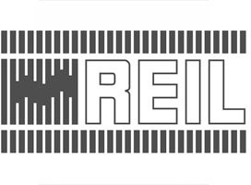

REIL



Indian Railway



Keshav Cement



Kirloskar



ATHA Group



SunilHitech



Malpani

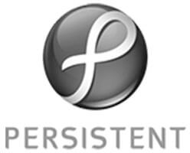

Persistent



Edelweiss



Vikram Tea



Paras Group

#### About Enrich

[Promoters](https://enrichenergy.com/promoters)

#### Projects

[View All Projects](https://enrichenergy.com/projects)

#### Business Solutions

[EPC Solutions](https://enrichenergy.com/business_offerings/epc-solutions/)

[Clientele](https://enrichenergy.com/clientele) [(https://enrichenergy.com/clientele)](https://enrichenergy.com/clientele)

[(https://enrichenergy.com/promoters)](https://enrichenergy.com/promoters)

[Achievement](https://enrichenergy.com/achievements)

[(https://enrichenergy.com/projects)](https://enrichenergy.com/projects)

[End to End](https://enrichenergy.com/projects/#home)

[(https://enrichenergy.com/business_offerings](https://enrichenergy.com/business_offerings/epc-solutions/)M[/ep](https://enrichenergy.com/business_offerings/epc-solutions/)[e](https://enrichenergy.com/video)[c-](https://enrichenergy.com/business_offerings/epc-solutions/)[dia Center](https://enrichenergy.com/video)

[solutions/)](https://enrichenergy.com/business_offerings/epc-solutions/)

[(https://enrichenergy.com/achievements)](https://enrichenergy.com/achievements)

[(https://enrichenergy.com/projects/#home)](https://enrichenergy.com/projects/#home)

[End to End Solutions](https://enrichenergy.com/business_offerings/end-to-end-solutions)

[(https://enrichenergy.com/video)](https://enrichenergy.com/video)

[CSR](https://enrichenergy.com/csr) [(https://enrichenergy.com/csr)](https://enrichenergy.com/csr)

[EPC](https://enrichenergy.com/projects/#menu1)

[(https://enrichenergy.com/business_offerings](https://enrichenergy.com/business_offerings/end-to-end-solutions)B[/en](https://enrichenergy.com/business_offerings/end-to-end-solutions)[lo](https://enrichenergy.com/blogs)[d-](https://enrichenergy.com/business_offerings/end-to-end-solutions)[g](https://enrichenergy.com/blogs)

[Brochures](https://enrichenergy.com/wp-content/uploads/2017/12/Enrich-Energy_Corp-Brochure_2017.pdf)

[(https://enrichenergy.com/projects/#menu1)](https://enrichenergy.com/projects/#menu1) [to-end-solutions)](https://enrichenergy.com/business_offerings/end-to-end-solutions)

[(https://enrichenergy.com/wp-](https://enrichenergy.com/wp-content/uploads/2017/12/Enrich-Energy_Corp-Brochure_2017.pdf)

[IPP](https://enrichenergy.com/projects/#menu2)

[Rooftop Solutions](https://enrichenergy.com/business_offerings/rooftop-solutions/)

[(https://enrichenergy.com/blogs)](https://enrichenergy.com/blogs)

[content/uploads/2017/12/Enrich-](https://enrichenergy.com/wp-content/uploads/2017/12/Enrich-Energy_Corp-Brochure_2017.pdf)

[(https://enrichenergy.com/projects/#menu2)](https://enrichenergy.com/projects/#menu2) [(https://enrichenergy.com/business_offerings/rooftop-](https://enrichenergy.com/business_offerings/rooftop-solutions/)

[Energy_Corp-Brochure_2017.pdf)](https://enrichenergy.com/wp-content/uploads/2017/12/Enrich-Energy_Corp-Brochure_2017.pdf)

[Rooftop](https://enrichenergy.com/projects/#menu3)

[solutions/)](https://enrichenergy.com/business_offerings/rooftop-solutions/)

#### [Careers](https://enrichenergy.com/career)

[(https://enrichenergy.com/projects/#menu3)](https://enrichenergy.com/projects/#menu3) [O & M Services](https://enrichenergy.com/business_offerings/om-services/)



[(https://enrichenergy.com/career)](https://enrichenergy.com/career)

[(https://www.linkedin.com/company/9316416/)](https://www.linkedin.com/company/9316416/)

[(https://enrichenergy.com/business_offerings/om-](https://enrichenergy.com/business_offerings/om-services/) [services/)](https://enrichenergy.com/business_offerings/om-services/)

[Energy Storage](https://enrichenergy.com/business_offerings/energystorage/) [(https://enrichenergy.com/business_offerings/energystorage/)](https://enrichenergy.com/business_offerings/energystorage/) [Value Added Services](https://enrichenergy.com/business_offerings/value-added-services/) [(https://enrichenergy.com/business_offerings/value-](https://enrichenergy.com/business_offerings/value-added-services/)

[added-services/)](https://enrichenergy.com/business_offerings/value-added-services/)

[Privacy Policy (https://enrichenergy.com/privacy-policy/)](https://enrichenergy.com/privacy-policy/) [Disclaimer (https://enrichenergy.com/disclaimer)](https://enrichenergy.com/disclaimer) [Reach Us (https://enrichenergy.com/contact-us)](https://enrichenergy.com/contact-us)

[Copyright 2018](https://enrichenergy.com/copyright) [(https://enrichenergy.com/copyright)](https://enrichenergy.com/copyright), Enrich Energy Pvt. Ltd.

# Testimonials



Enel is pleased with Enrich Energy’s competences, fair business practices and partnership approach.

#### Enel Green Power (EGP)

About Enrich

[Promoters](https://enrichenergy.com/promoters)

#### Projects

[View All Projects](https://enrichenergy.com/projects)

#### Business Solutions

[EPC Solutions](https://enrichenergy.com/business_offerings/epc-solutions/)

[Clientele](https://enrichenergy.com/clientele) [(https://enrichenergy.com/clientele)](https://enrichenergy.com/clientele)

[(https://enrichenergy.com/promoters)](https://enrichenergy.com/promoters)

**REACH US**

[(https://enrichenergy.com/projects)](https://enrichenergy.com/projects)

[(https://enrichenergy.com/business_offerings/epc-](https://enrichenergy.com/business_offerings/epc-solutions/)

[Achievement](https://enrichenergy.com/achievements) [(https://enrichenergy.com/achievements)](https://enrichenergy.com/achievements)

[End to End](https://enrichenergy.com/projects/#home) [(https://enrichenergy.com/projects/#home)](https://enrichenergy.com/projects/#home)

[solutions/)](https://enrichenergy.com/business_offerings/epc-solutions/)

[End to End Solutions](https://enrichenergy.com/business_offerings/end-to-end-solutions)

[Media Center](https://enrichenergy.com/video) [(https://enrichenergy.com/video)](https://enrichenergy.com/video)

[CSR](https://enrichenergy.com/csr) [(https://enrichenergy.com/csr)](https://enrichenergy.com/csr)

[EPC](https://enrichenergy.com/projects/#menu1)

[(https://enrichenergy.com/business_offerings/end-](https://enrichenergy.com/business_offerings/end-to-end-solutions)

[Brochures](https://enrichenergy.com/wp-content/uploads/2017/12/Enrich-Energy_Corp-Brochure_2017.pdf)

[(https://enrichenergy.com/projects/#menu1)](https://enrichenergy.com/projects/#menu1) [to-end-solutions)](https://enrichenergy.com/business_offerings/end-to-end-solutions)

#### [Blog](https://enrichenergy.com/blogs)

[(https://enrichenergy.com/wp-](https://enrichenergy.com/wp-content/uploads/2017/12/Enrich-Energy_Corp-Brochure_2017.pdf)

[IPP](https://enrichenergy.com/projects/#menu2)

[Rooftop Solutions](https://enrichenergy.com/business_offerings/rooftop-solutions/)

[(https://enrichenergy.com/blogs)](https://enrichenergy.com/blogs)

[content/uploads/2017/12/Enrich-](https://enrichenergy.com/wp-content/uploads/2017/12/Enrich-Energy_Corp-Brochure_2017.pdf) [(https://enrichenergy.com/projects/#menu2)](https://enrichenergy.com/projects/#menu2) [(https://enrichenergy.com/business_offerings/rooftop-](https://enrichenergy.com/business_offerings/rooftop-solutions/)

[Energy_Corp-Brochure_2017.pdf)](https://enrichenergy.com/wp-content/uploads/2017/12/Enrich-Energy_Corp-Brochure_2017.pdf)

[Rooftop](https://enrichenergy.com/projects/#menu3)

[solutions/)](https://enrichenergy.com/business_offerings/rooftop-solutions/)

#### [Careers](https://enrichenergy.com/career)

[(https://enrichenergy.com/projects/#menu3)](https://enrichenergy.com/projects/#menu3) [O & M Services](https://enrichenergy.com/business_offerings/om-services/)



[(https://enrichenergy.com/career)](https://enrichenergy.com/career)

[(https://www.linkedin.com/company/9316416/)](https://www.linkedin.com/company/9316416/)

[(https://enrichenergy.com/business_offerings/om-](https://enrichenergy.com/business_offerings/om-services/) [services/)](https://enrichenergy.com/business_offerings/om-services/)

[Energy Storage](https://enrichenergy.com/business_offerings/energystorage/) [(https://enrichenergy.com/business_offerings/energystorage/)](https://enrichenergy.com/business_offerings/energystorage/) [Value Added Services](https://enrichenergy.com/business_offerings/value-added-services/) [(https://enrichenergy.com/business_offerings/value-](https://enrichenergy.com/business_offerings/value-added-services/)

[added-services/)](https://enrichenergy.com/business_offerings/value-added-services/)

[Privacy Policy (https://enrichenergy.com/privacy-policy/)](https://enrichenergy.com/privacy-policy/) [Disclaimer (https://enrichenergy.com/disclaimer)](https://enrichenergy.com/disclaimer) [Reach Us (https://enrichenergy.com/contact-us)](https://enrichenergy.com/contact-us)

[Copyright 2018](https://enrichenergy.com/copyright) [(https://enrichenergy.com/copyright)](https://enrichenergy.com/copyright), Enrich Energy Pvt. Ltd.

**REACH US**

# Brochures

[Enrich Energy Corporate Brochure](http://sysweave.com/beta/enrich-wp/wp-content/uploads/2017/12/Enrich-Energy_Corp-Brochure_2017.pdf) [(http://sysweave.com/beta/enrich-](http://sysweave.com/beta/enrich-wp/wp-content/uploads/2017/12/Enrich-Energy_Corp-Brochure_2017.pdf) [wp/wp-](http://sysweave.com/beta/enrich-wp/wp-content/uploads/2017/12/Enrich-Energy_Corp-Brochure_2017.pdf) [content/uploads/2017/12/Enrich-](http://sysweave.com/beta/enrich-wp/wp-content/uploads/2017/12/Enrich-Energy_Corp-Brochure_2017.pdf) [Energy_Corp-Brochure_2017.pdf)](http://sysweave.com/beta/enrich-wp/wp-content/uploads/2017/12/Enrich-Energy_Corp-Brochure_2017.pdf)

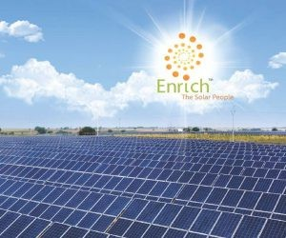

[(http://sysweave.com/beta/enrich- wp/wp- content/uploads/2017/12/Enrich- Energy_Corp- Brochure_2017.pdf)](http://sysweave.com/beta/enrich-wp/wp-content/uploads/2017/12/Enrich-Energy_Corp-Brochure_2017.pdf)

#### About Enrich

[Promoters](https://enrichenergy.com/promoters)

#### Projects

[View All Projects](https://enrichenergy.com/projects)

#### Business Solutions

[EPC Solutions](https://enrichenergy.com/business_offerings/epc-solutions/)

[Clientele](https://enrichenergy.com/clientele) [(https://enrichenergy.com/clientele)](https://enrichenergy.com/clientele)

[(https://enrichenergy.com/promoters)](https://enrichenergy.com/promoters)

[Achievement](https://enrichenergy.com/achievements)

[(https://enrichenergy.com/projects)](https://enrichenergy.com/projects)

[End to End](https://enrichenergy.com/projects/#home)

[(https://enrichenergy.com/business_offerings](https://enrichenergy.com/business_offerings/epc-solutions/)M[/ep](https://enrichenergy.com/business_offerings/epc-solutions/)[e](https://enrichenergy.com/video)[c-](https://enrichenergy.com/business_offerings/epc-solutions/)[dia Center](https://enrichenergy.com/video)

[solutions/)](https://enrichenergy.com/business_offerings/epc-solutions/)

[(https://enrichenergy.com/achievements)](https://enrichenergy.com/achievements)

[(https://enrichenergy.com/projects/#home)](https://enrichenergy.com/projects/#home)

[End to End Solutions](https://enrichenergy.com/business_offerings/end-to-end-solutions)

[(https://enrichenergy.com/video)](https://enrichenergy.com/video)

[CSR](https://enrichenergy.com/csr) [(https://enrichenergy.com/csr)](https://enrichenergy.com/csr)

[EPC](https://enrichenergy.com/projects/#menu1)

[(https://enrichenergy.com/business_offerings](https://enrichenergy.com/business_offerings/end-to-end-solutions)B[/en](https://enrichenergy.com/business_offerings/end-to-end-solutions)[lo](https://enrichenergy.com/blogs)[d-](https://enrichenergy.com/business_offerings/end-to-end-solutions)[g](https://enrichenergy.com/blogs)

[Brochures](https://enrichenergy.com/wp-content/uploads/2017/12/Enrich-Energy_Corp-Brochure_2017.pdf)

[(https://enrichenergy.com/projects/#menu1)](https://enrichenergy.com/projects/#menu1) [to-end-solutions)](https://enrichenergy.com/business_offerings/end-to-end-solutions)

[(https://enrichenergy.com/wp-](https://enrichenergy.com/wp-content/uploads/2017/12/Enrich-Energy_Corp-Brochure_2017.pdf)

[IPP](https://enrichenergy.com/projects/#menu2)

[Rooftop Solutions](https://enrichenergy.com/business_offerings/rooftop-solutions/)

[(https://enrichenergy.com/blogs)](https://enrichenergy.com/blogs)

[content/uploads/2017/12/Enrich-](https://enrichenergy.com/wp-content/uploads/2017/12/Enrich-Energy_Corp-Brochure_2017.pdf)

[(https://enrichenergy.com/projects/#menu2)](https://enrichenergy.com/projects/#menu2) [(https://enrichenergy.com/business_offerings/rooftop-](https://enrichenergy.com/business_offerings/rooftop-solutions/)

[Energy_Corp-Brochure_2017.pdf)](https://enrichenergy.com/wp-content/uploads/2017/12/Enrich-Energy_Corp-Brochure_2017.pdf)

[Rooftop](https://enrichenergy.com/projects/#menu3)

[solutions/)](https://enrichenergy.com/business_offerings/rooftop-solutions/)

#### [Careers](https://enrichenergy.com/career)

[(https://enrichenergy.com/projects/#menu3)](https://enrichenergy.com/projects/#menu3) [O & M Services](https://enrichenergy.com/business_offerings/om-services/)



[(https://enrichenergy.com/career)](https://enrichenergy.com/career)

[(https://www.linkedin.com/company/9316416/)](https://www.linkedin.com/company/9316416/)

[(https://enrichenergy.com/business_offerings/om-](https://enrichenergy.com/business_offerings/om-services/) [services/)](https://enrichenergy.com/business_offerings/om-services/)

[Energy Storage](https://enrichenergy.com/business_offerings/energystorage/) [(https://enrichenergy.com/business_offerings/energystorage/)](https://enrichenergy.com/business_offerings/energystorage/) [Value Added Services](https://enrichenergy.com/business_offerings/value-added-services/) [(https://enrichenergy.com/business_offerings/value-](https://enrichenergy.com/business_offerings/value-added-services/)

[added-services/)](https://enrichenergy.com/business_offerings/value-added-services/)

[Privacy Policy (https://enrichenergy.com/privacy-policy/)](https://enrichenergy.com/privacy-policy/) [Disclaimer (https://enrichenergy.com/disclaimer)](https://enrichenergy.com/disclaimer) [Reach Us (https://enrichenergy.com/contact-us)](https://enrichenergy.com/contact-us)

[Copyright 2018](https://enrichenergy.com/copyright) [(https://enrichenergy.com/copyright)](https://enrichenergy.com/copyright), Enrich Energy Pvt. Ltd.

**REACH US**

# Videos

[Enrich Energy Corporate Video](https://www.youtube.com/watch?v=yXAVUywv3uM)

#### About Enrich

[Promoters](https://enrichenergy.com/promoters)

#### Projects

[View All Projects](https://enrichenergy.com/projects)

#### Business Solutions

[EPC Solutions](https://enrichenergy.com/business_offerings/epc-solutions/)

[Clientele](https://enrichenergy.com/clientele) [(https://enrichenergy.com/clientele)](https://enrichenergy.com/clientele)

[(https://enrichenergy.com/promoters)](https://enrichenergy.com/promoters)

[Achievement](https://enrichenergy.com/achievements)

[(https://enrichenergy.com/projects)](https://enrichenergy.com/projects)

[End to End](https://enrichenergy.com/projects/#home)

[(https://enrichenergy.com/business_offerings](https://enrichenergy.com/business_offerings/epc-solutions/)M[/ep](https://enrichenergy.com/business_offerings/epc-solutions/)[e](https://enrichenergy.com/video)[c-](https://enrichenergy.com/business_offerings/epc-solutions/)[dia Center](https://enrichenergy.com/video)

[solutions/)](https://enrichenergy.com/business_offerings/epc-solutions/)

[(https://enrichenergy.com/achievements)](https://enrichenergy.com/achievements)

[(https://enrichenergy.com/projects/#home)](https://enrichenergy.com/projects/#home)

[End to End Solutions](https://enrichenergy.com/business_offerings/end-to-end-solutions)

[(https://enrichenergy.com/video)](https://enrichenergy.com/video)

[CSR](https://enrichenergy.com/csr) [(https://enrichenergy.com/csr)](https://enrichenergy.com/csr)

[EPC](https://enrichenergy.com/projects/#menu1)

[(https://enrichenergy.com/business_offerings](https://enrichenergy.com/business_offerings/end-to-end-solutions)B[/en](https://enrichenergy.com/business_offerings/end-to-end-solutions)[lo](https://enrichenergy.com/blogs)[d-](https://enrichenergy.com/business_offerings/end-to-end-solutions)[g](https://enrichenergy.com/blogs)

[Brochures](https://enrichenergy.com/wp-content/uploads/2017/12/Enrich-Energy_Corp-Brochure_2017.pdf)

[(https://enrichenergy.com/projects/#menu1)](https://enrichenergy.com/projects/#menu1) [to-end-solutions)](https://enrichenergy.com/business_offerings/end-to-end-solutions)

[(https://enrichenergy.com/wp-](https://enrichenergy.com/wp-content/uploads/2017/12/Enrich-Energy_Corp-Brochure_2017.pdf)

[IPP](https://enrichenergy.com/projects/#menu2)

[Rooftop Solutions](https://enrichenergy.com/business_offerings/rooftop-solutions/)

[(https://enrichenergy.com/blogs)](https://enrichenergy.com/blogs)

[content/uploads/2017/12/Enrich-](https://enrichenergy.com/wp-content/uploads/2017/12/Enrich-Energy_Corp-Brochure_2017.pdf)

[(https://enrichenergy.com/projects/#menu2)](https://enrichenergy.com/projects/#menu2) [(https://enrichenergy.com/business_offerings/rooftop-](https://enrichenergy.com/business_offerings/rooftop-solutions/)

[Energy_Corp-Brochure_2017.pdf)](https://enrichenergy.com/wp-content/uploads/2017/12/Enrich-Energy_Corp-Brochure_2017.pdf)

[Rooftop](https://enrichenergy.com/projects/#menu3)

[solutions/)](https://enrichenergy.com/business_offerings/rooftop-solutions/)

#### [Careers](https://enrichenergy.com/career)

[(https://enrichenergy.com/projects/#menu3)](https://enrichenergy.com/projects/#menu3) [O & M Services](https://enrichenergy.com/business_offerings/om-services/)



[(https://enrichenergy.com/career)](https://enrichenergy.com/career)

[(https://www.linkedin.com/company/9316416/)](https://www.linkedin.com/company/9316416/)

[(https://enrichenergy.com/business_offerings/om-](https://enrichenergy.com/business_offerings/om-services/) [services/)](https://enrichenergy.com/business_offerings/om-services/)

[Energy Storage](https://enrichenergy.com/business_offerings/energystorage/) [(https://enrichenergy.com/business_offerings/energystorage/)](https://enrichenergy.com/business_offerings/energystorage/) [Value Added Services](https://enrichenergy.com/business_offerings/value-added-services/) [(https://enrichenergy.com/business_offerings/value-](https://enrichenergy.com/business_offerings/value-added-services/)

[added-services/)](https://enrichenergy.com/business_offerings/value-added-services/)

[Privacy Policy (https://enrichenergy.com/privacy-policy/)](https://enrichenergy.com/privacy-policy/) [Disclaimer (https://enrichenergy.com/disclaimer)](https://enrichenergy.com/disclaimer) [Reach Us (https://enrichenergy.com/contact-us)](https://enrichenergy.com/contact-us)

[Copyright 2018](https://enrichenergy.com/copyright) [(https://enrichenergy.com/copyright)](https://enrichenergy.com/copyright), Enrich Energy Pvt. Ltd.

Blogs

##### REACH US

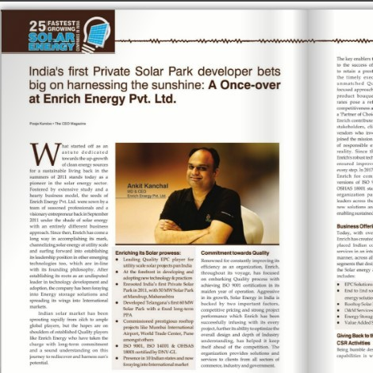

( [https://enrichenergy .com/enrich-energy-listed-amongst-fastest-growing- solar-energy-companies/)](https://enrichenergy.com/enrich-energy-listed-amongst-fastest-growing-solar-energy-companies/)

Enrich Energy listed amongst fastest growing Solar & Energy companies

The CEO magazine ranks Enrich Energy amongst top 25 fastest growing Solar & Energy companies in India, in its May 2018 issue. The magazine also featured an article by our MD & CEO, Ankit Kanchal.

Click Here for More..

[Read more (https://enrichenergy.com/enrich-energy-listed- amongst-fastest-growing-solar-energy-companies/)](https://enrichenergy.com/enrich-energy-listed-amongst-fastest-growing-solar-energy-companies/)

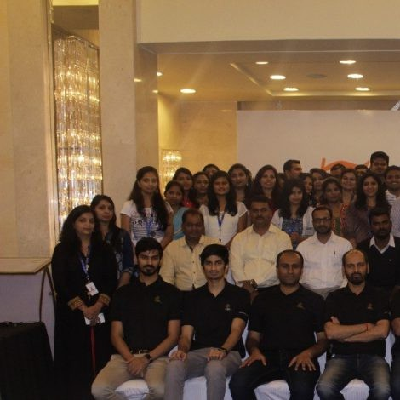

[(https://enrichenergy.com/team-enrich-celebrates-its-7th-foundation-day- 03rd-sep-2017/)](https://enrichenergy.com/team-enrich-celebrates-its-7th-foundation-day-03rd-sep-2017/)

Team Enrich celebrates its 7th Foundation day (03rd Sep 2017)

Happy faces and hearts filled with pride, celebrate the foundation day at Taj Vivanta, Pune & Hotel Sarovar, Solapur. The celebration was lit by inspiring speeches by Mr. Vijay Zawar (Chairman) & Mr. Ankit Kanchal (Managing Director). The speeches were both nostalgic about its early foundation day and its journey of 6 years, and was […]

[Read more (https://enrichenergy.com/team-enrich-celebrates-its- 7th-foundation-day-03rd-sep-2017/)](https://enrichenergy.com/team-enrich-celebrates-its-7th-foundation-day-03rd-sep-2017/)

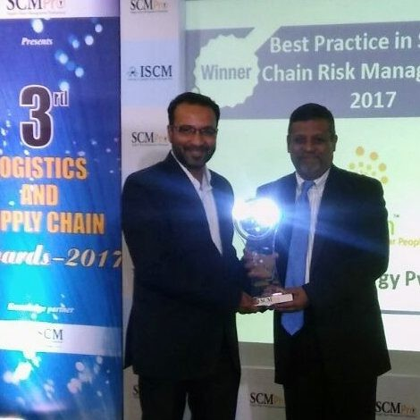

[(https://enrichenergy.com/iscm-bestows-enrich-energy-with-best-practice- in-supply-chain-risk-management-2017-award/)](https://enrichenergy.com/iscm-bestows-enrich-energy-with-best-practice-in-supply-chain-risk-management-2017-award/)

ISCM bestows Enrich Energy with “Best Practice in Supply Chain Risk Management – 2017” award

This year’s ISCM awards were widely contested by companies across industries. Amongst the awards winners under various categories were some of the foremost leading names in Indian industry. Amongst the award winners, Enrich Energy too stood tall when it was awarded for “Best Practice in Supply Chain Risk Management – 2017”. This is yet another recognition [...]

[Read more (https://enrichenergy.com/iscm-bestows-enrich- energy-with-best-practice-in-supply-chain-risk-management- 2017-award/)](https://enrichenergy.com/iscm-bestows-enrich-energy-with-best-practice-in-supply-chain-risk-management-2017-award/)

#### About Enrich

[Promoters](https://enrichenergy.com/promoters)

#### Projects

[View All Projects](https://enrichenergy.com/projects)

#### Business Solutions

[EPC Solutions](https://enrichenergy.com/business_offerings/epc-solutions/)

[Clientele](https://enrichenergy.com/clientele) [(https://enrichenergy.com/clientele)](https://enrichenergy.com/clientele)

[(https://enrichenergy.com/promoters)](https://enrichenergy.com/promoters)

[Achievement](https://enrichenergy.com/achievements)

[(https://enrichenergy.com/projects)](https://enrichenergy.com/projects)

[End to End](https://enrichenergy.com/projects/#home)

[(https://enrichenergy.com/business_offerings](https://enrichenergy.com/business_offerings/epc-solutions/)M[/ep](https://enrichenergy.com/business_offerings/epc-solutions/)[e](https://enrichenergy.com/video)[c-](https://enrichenergy.com/business_offerings/epc-solutions/)[dia Center](https://enrichenergy.com/video)

[solutions/)](https://enrichenergy.com/business_offerings/epc-solutions/)

[(https://enrichenergy.com/achievements)](https://enrichenergy.com/achievements)

[(https://enrichenergy.com/projects/#home)](https://enrichenergy.com/projects/#home)

[End to End Solutions](https://enrichenergy.com/business_offerings/end-to-end-solutions)

[(https://enrichenergy.com/video)](https://enrichenergy.com/video)

[CSR](https://enrichenergy.com/csr) [(https://enrichenergy.com/csr)](https://enrichenergy.com/csr)

[EPC](https://enrichenergy.com/projects/#menu1)

[(https://enrichenergy.com/business_offerings](https://enrichenergy.com/business_offerings/end-to-end-solutions)B[/en](https://enrichenergy.com/business_offerings/end-to-end-solutions)[lo](https://enrichenergy.com/blogs)[d-](https://enrichenergy.com/business_offerings/end-to-end-solutions)[g](https://enrichenergy.com/blogs)

[Brochures](https://enrichenergy.com/wp-content/uploads/2017/12/Enrich-Energy_Corp-Brochure_2017.pdf)

[(https://enrichenergy.com/projects/#menu1)](https://enrichenergy.com/projects/#menu1) [to-end-solutions)](https://enrichenergy.com/business_offerings/end-to-end-solutions)

[(https://enrichenergy.com/wp-](https://enrichenergy.com/wp-content/uploads/2017/12/Enrich-Energy_Corp-Brochure_2017.pdf)

[IPP](https://enrichenergy.com/projects/#menu2)

[Rooftop Solutions](https://enrichenergy.com/business_offerings/rooftop-solutions/)

[(https://enrichenergy.com/blogs)](https://enrichenergy.com/blogs)

[content/uploads/2017/12/Enrich-](https://enrichenergy.com/wp-content/uploads/2017/12/Enrich-Energy_Corp-Brochure_2017.pdf)

[(https://enrichenergy.com/projects/#menu2)](https://enrichenergy.com/projects/#menu2) [(https://enrichenergy.com/business_offerings/rooftop-](https://enrichenergy.com/business_offerings/rooftop-solutions/)

[Energy_Corp-Brochure_2017.pdf)](https://enrichenergy.com/wp-content/uploads/2017/12/Enrich-Energy_Corp-Brochure_2017.pdf)

[Rooftop](https://enrichenergy.com/projects/#menu3)

[solutions/)](https://enrichenergy.com/business_offerings/rooftop-solutions/)

#### [Careers](https://enrichenergy.com/career)

[(https://enrichenergy.com/projects/#menu3)](https://enrichenergy.com/projects/#menu3) [O & M Services](https://enrichenergy.com/business_offerings/om-services/)



[(https://enrichenergy.com/career)](https://enrichenergy.com/career)

[(https://www.linkedin.com/company/9316416/)](https://www.linkedin.com/company/9316416/)

[(https://enrichenergy.com/business_offerings/om-](https://enrichenergy.com/business_offerings/om-services/) [services/)](https://enrichenergy.com/business_offerings/om-services/)

[Energy Storage](https://enrichenergy.com/business_offerings/energystorage/) [(https://enrichenergy.com/business_offerings/energystorage/)](https://enrichenergy.com/business_offerings/energystorage/) [Value Added Services](https://enrichenergy.com/business_offerings/value-added-services/) [(https://enrichenergy.com/business_offerings/value-](https://enrichenergy.com/business_offerings/value-added-services/)

[added-services/)](https://enrichenergy.com/business_offerings/value-added-services/)

[Privacy Policy (https://enrichenergy.com/privacy-policy/)](https://enrichenergy.com/privacy-policy/) [Disclaimer (https://enrichenergy.com/disclaimer)](https://enrichenergy.com/disclaimer) [Reach Us (https://enrichenergy.com/contact-us)](https://enrichenergy.com/contact-us)

[Copyright 2018](https://enrichenergy.com/copyright) [(https://enrichenergy.com/copyright)](https://enrichenergy.com/copyright), Enrich Energy Pvt. Ltd.

# Reach Us

### Get In Touch

Full Name

**REACH US**

Address

Head office:

[302, Third Floor, ’The Orion](https://goo.gl/maps/sQf2ruMdy9q) [Building’, 11/1C, Koregaon Park](https://goo.gl/maps/sQf2ruMdy9q) [Road,](https://goo.gl/maps/sQf2ruMdy9q)

Company

[Pune – 411 001 Maharashtra,](https://goo.gl/maps/sQf2ruMdy9q) [INDIA](https://goo.gl/maps/sQf2ruMdy9q)

Designation

[(https://goo.gl/maps/sQf2ruMdy9q)](https://goo.gl/maps/sQf2ruMdy9q)

Phone: + 91 20 2605 0080

Email ID

(tel:+912026050080)/ 84 (tel:+912026050084) Fax: + 91 20 2605 0079

Contact Number

Email: [info@enrichenergy.com](mailto:info@enrichenergy.com) [(mailto:info@enrichenergy.com)](mailto:info@enrichenergy.com)

Enter your massage for us here. We will get back to you within 2 business days.

Type of Enquiry

 End to End  EPC  Rooftop  Energy Storage  O&M  others

Send

Mumbai:

Pinnacle Corporate Park A-Wing, Block-G, Bldg-19 10th Floor, Office - 17 A

Bandra-Kurla Complex, Bandra(East), Mumbai – 400 051

Maharashtra, INDIA

Hyderabad:

102, Pearl Point Apartments, Erram Manzil, Beside IIPM Tower, Opposite Hotel Taj Deccan, Banjara Hills, Hyderabad - 500034 Telangana, INDIA

Kolhapur:

301, Third Floor, Omega Tower, 9th lane, Rajarampuri, Kolhapur - 416008 Maharashtra, INDIA

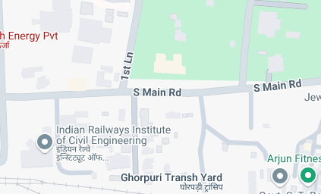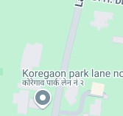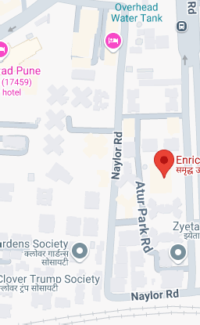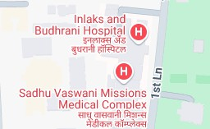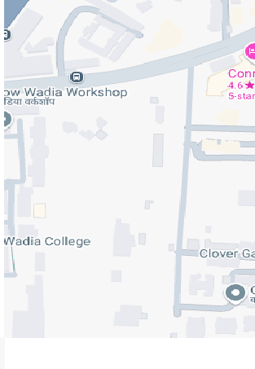

Enrich Energy Pvt Ltd

The Orion, 302,11/1C, Koregaon Rd, Opposite Don Bosco Youth Centre, Ragvilas Society, Koregaon Park, Pune, Maharashtra 411001

Directions

3.9 [56 reviews](https://search.google.com/local/reviews?placeid=ChIJbUQVDf_AwjsRRuscld6wxkQ&q=Enrich%2BEnergy%2BPvt.%2BLtd.&hl=en&gl=IN)

[View larger map](https://maps.google.com/maps?ll=18.533598%2C73.885298&z=17&t=m&hl=en-US&gl=US&mapclient=embed&cid=4955842909998738246)

[Report a map error](https://www.google.com/maps/%4018.5335983%2C73.8852976%2C17z/data%3D!10m1!1e1!12b1?source=apiv3&rapsrc=apiv3)

Map data ©2024 Google

#### About Enrich

[Promoters](https://enrichenergy.com/promoters)

#### Projects

[View All Projects](https://enrichenergy.com/projects)

#### Business Solutions

[EPC Solutions](https://enrichenergy.com/business_offerings/epc-solutions/)

[Clientele](https://enrichenergy.com/clientele) [(https://enrichenergy.com/clientele)](https://enrichenergy.com/clientele)

[(https://enrichenergy.com/promoters)](https://enrichenergy.com/promoters)

[Achievement](https://enrichenergy.com/achievements)

[(https://enrichenergy.com/projects)](https://enrichenergy.com/projects)

[End to End](https://enrichenergy.com/projects/#home)

[(https://enrichenergy.com/business_offerings](https://enrichenergy.com/business_offerings/epc-solutions/)M[/ep](https://enrichenergy.com/business_offerings/epc-solutions/)[e](https://enrichenergy.com/video)[c-](https://enrichenergy.com/business_offerings/epc-solutions/)[dia Center](https://enrichenergy.com/video)

[solutions/)](https://enrichenergy.com/business_offerings/epc-solutions/)

[(https://enrichenergy.com/achievements)](https://enrichenergy.com/achievements)

[(https://enrichenergy.com/projects/#home)](https://enrichenergy.com/projects/#home)

[End to End Solutions](https://enrichenergy.com/business_offerings/end-to-end-solutions)

[(https://enrichenergy.com/video)](https://enrichenergy.com/video)

[CSR](https://enrichenergy.com/csr) [(https://enrichenergy.com/csr)](https://enrichenergy.com/csr)

[EPC](https://enrichenergy.com/projects/#menu1)

[(https://enrichenergy.com/business_offerings/end-](https://enrichenergy.com/business_offerings/end-to-end-solutions)

[(https://enrichenergy.com/projects/#menu1)](https://enrichenergy.com/projects/#menu1) [to-end-solutions)](https://enrichenergy.com/business_offerings/end-to-end-solutions)

[Brochures](https://enrichenergy.com/wp-content/uploads/2017/12/Enrich-Energy_Corp-Brochure_2017.pdf)

[IPP](https://enrichenergy.com/projects/#menu2)

[Rooftop Solutions](https://enrichenergy.com/business_offerings/rooftop-solutions/)

#### [Blog](https://enrichenergy.com/blogs)

[(https://enrichenergy.com/wp-](https://enrichenergy.com/wp-content/uploads/2017/12/Enrich-Energy_Corp-Brochure_2017.pdf)

[(https://enrichenergy.com/projects/#menu2)](https://enrichenergy.com/projects/#menu2) [(https://enrichenergy.com/business_offerings](https://enrichenergy.com/business_offerings/rooftop-solutions/)([/r](https://enrichenergy.com/business_offerings/rooftop-solutions/)[h](https://enrichenergy.com/blogs)[oo](https://enrichenergy.com/business_offerings/rooftop-solutions/)[t](https://enrichenergy.com/blogs)[f](https://enrichenergy.com/business_offerings/rooftop-solutions/)[t](https://enrichenergy.com/blogs)[t](https://enrichenergy.com/business_offerings/rooftop-solutions/)[p](https://enrichenergy.com/blogs)[op](https://enrichenergy.com/business_offerings/rooftop-solutions/)[s](https://enrichenergy.com/blogs)[-](https://enrichenergy.com/business_offerings/rooftop-solutions/)[://enrichenergy.com/blogs)](https://enrichenergy.com/blogs)

[content/uploads/2017/12/Enrich-](https://enrichenergy.com/wp-content/uploads/2017/12/Enrich-Energy_Corp-Brochure_2017.pdf)

[Rooftop](https://enrichenergy.com/projects/#menu3)

[solutions/)](https://enrichenergy.com/business_offerings/rooftop-solutions/)

[Energy_Corp-Brochure_2017.pdf)](https://enrichenergy.com/wp-content/uploads/2017/12/Enrich-Energy_Corp-Brochure_2017.pdf)

[(https://enrichenergy.com/projects/#menu3)](https://enrichenergy.com/projects/#menu3) [O & M Services](https://enrichenergy.com/business_offerings/om-services/)

#### [Careers](https://enrichenergy.com/career)



[(https://www.linkedin.com/company/9316416/)](https://www.linkedin.com/company/9316416/)

[(https://enrichenergy.com/business_offerings](https://enrichenergy.com/business_offerings/om-services/)([/o](https://enrichenergy.com/business_offerings/om-services/)[h](https://enrichenergy.com/career)[m](https://enrichenergy.com/business_offerings/om-services/)[t](https://enrichenergy.com/career)[-](https://enrichenergy.com/business_offerings/om-services/)[tps://enrichenergy.com/career)](https://enrichenergy.com/career) [services/)](https://enrichenergy.com/business_offerings/om-services/)

[Energy Storage](https://enrichenergy.com/business_offerings/energystorage/) [(https://enrichenergy.com/business_offerings/energystorage/)](https://enrichenergy.com/business_offerings/energystorage/) [Value Added Services](https://enrichenergy.com/business_offerings/value-added-services/) [(https://enrichenergy.com/business_offerings/value-](https://enrichenergy.com/business_offerings/value-added-services/)

[added-services/)](https://enrichenergy.com/business_offerings/value-added-services/)

[Privacy Policy (https://enrichenergy.com/privacy-policy/)](https://enrichenergy.com/privacy-policy/) [Disclaimer (https://enrichenergy.com/disclaimer)](https://enrichenergy.com/disclaimer) [Reach Us (https://enrichenergy.com/contact-us)](https://enrichenergy.com/contact-us)

[Copyright 2018](https://enrichenergy.com/copyright) [(https://enrichenergy.com/copyright)](https://enrichenergy.com/copyright), Enrich Energy Pvt. Ltd.